
info@argusoft.com www.argusoft.com

Technical Proposal
A proposal for Assignment

Design, Development and Maintenance of MoWCA Integrated MIS

Submitted on
30/03/2026

MOWCA, Bangladesh

Table of Contents
Table of Contents 2
Compliance Matrix - Evaluation Criteria 4
About the Organisation - Argusoft India Ltd 8
Company Profile 8
Why we do, what we do 9
Registration Certificate and GST Certificate 10
Geographical Presence 12
Relevant Experience (Past Project References) 13
Public Health Management Platform (PHMP / MEDplat-based Implementations) 13
TeCHO+ – Government of Gujarat, India 14
eKavach – National Health Mission, Uttar Pradesh, India 14
EWARS – World Health Organization (Global Deployment) 15
Technical Proposal / Methodology Proposed in the Proposal 16
Scope of Work - Our Understanding 16
Background 16
Objectives of the RFP 16
Our Understanding of Tasks to be Done 17
Key Deliverables 19
Why Argusoft? 20
Deep Experience in Government Digitization and Social Sector Platforms 20
Proven Capability in Building Scalable, Mission-Critical Platforms 21
Strong Expertise in Workflow-Driven System Design 21
Interoperability and Integration Expertise 21
User-Centric Design and Field-Level Practicality 22
Proven Ability to Successfully Deliver and Operationalize Systems on the Ground 22
Commitment to Capacity Building and Sustainability 23
Proven Track Record with Global and Government Stakeholders 23
Conclusion 23
Approach 24
Methodology 26
Functional Landscape Diagram 28
Proposed Solution 28
Front-end (Presentation Layer/Tier) 30
API - Application Programming Interface Layer/Tier 32
Data Access Layer 33
Important Modules 33
Administrative module, Roles and RBAC (Role-based access controls) 36
Beneficiary Management 37
Benefit & Payment Management 40
VWB Program-Specific Modules 42
Grievance Redress System (GRS) 44
Monitoring, Evaluation & Reporting 46
External API Integrations 47
Additional Features 48
Security Features 49
Data Governance Framework and Data Protection Impact Assessment (DPIA) 50
Helpdesk & Support Module 52
Mobile Application 52
Proposed Tech Stack 54
Hosting 56
Proposed Work Plan 57
Phase 1: Inception, Requirement Finalization & Detailed Planning (Month 1) 58
Phase 2: System Design, Architecture & Prototyping (Month 2) 58
Phase 3: Development & Integration (Months 3–4) 59
Phase 4: Testing, UAT & Security Validation (Months 4–6) 60
Phase 5: Deployment, Training & Go-Live (Month 7) 60
Phase 6: Post-Go-Live Support & Maintenance (Months 7–18) 60
Quality Assurance Management 62
Training and Capacity Building 66
Documentation 69
Support, Maintenance & SLA Requirements 72
Key Personnels 76
Mayank Modi - Project Manager (PMP Certified) 76
Nihar Patel - Sr. Full Stack Developer 80
Shrey Vyas - Sr. Full Stack Developer 84
Yashvi Pomal - Lead Business Analyst 88
Anjali Gajjar - Lead Software Quality Analyst 91
Manoj John - UI/UX Specialist 94
Documentary Proofs - Projects 98
Techo + - DNHDD _UT Admin 98
CHIP - Zambia 100
EWARS 101
PPC, Jamaica 110
SOFY, KPMG 111

Compliance Matrix - Evaluation Criteria
Argusoft has carefully reviewed the Terms of Reference (TOR) and confirms full compliance with all functional, technical, and operational requirements. The table below provides a summary of key compliance areas, demonstrating alignment with mandatory requirements and proposed approach.
# | TOR Requirement | Compliance Status | Argusoft’s Approach / Remarks
1 | End-to-end MIS for MCBP & VWB programs | ✔️ Fully Compliant | Configurable, modular MIS covering beneficiary lifecycle, payments, savings, food distribution, and GRS
2 | Workflow-based system with multi-level approvals | ✔️ Fully Compliant | Configurable workflow engine supporting role-based approvals and audit trails
3 | Beneficiary registration and lifecycle management | ✔️ Fully Compliant | End-to-end tracking from enrollment to benefit delivery and monitoring
4 | Integration with national systems (NID, health, G2P) | ✔️ Fully Compliant | API-first architecture enabling secure and scalable integrations
5 | Built-in Help Desk / Ticketing Module | ✔️ Fully Compliant | Fully integrated helpdesk module with SLA tracking, escalation, and reporting
6 | Grievance Redress System (GRS) | ✔️ Fully Compliant | Integrated GRS linked with beneficiary and program workflows
7 | Mobile and offline capability | ✔️ Fully Compliant | Offline-first mobile applications with sync capabilities for field users
8 | Multilingual support (Bangla & English) | ✔️ Fully Compliant | Fully localized UI and training materials in Bangla and English
9 | Accessibility (WCAG 2.1 Level AA) | ✔️ Fully Compliant | Accessible UI design with compliance validation
10 | Accessibility testing with persons with disabilities | ✔️ Fully Compliant | Dedicated UAT sessions with disabled users and assistive technology validation
11 | Data security and privacy | ✔️ Fully Compliant | Encryption, role-based access control, audit logs, and secure data handling
12 | Data Governance Framework | ✔️ Fully Compliant | Defined data ownership, stewardship, lifecycle policies, and compliance mechanisms
13 | Data Protection Impact Assessment (DPIA) | ✔️ Fully Compliant | Formal DPIA conducted with risk assessment and mitigation strategies
14 | Auditability and traceability | ✔️ Fully Compliant | Complete audit trails for all transactions and system activities
15 | Performance and scalability | ✔️ Fully Compliant | Cloud-ready architecture supporting high user loads and transactions
16 | Disaster Recovery (DR) and Business Continuity | ✔️ Fully Compliant | DR environment with defined RPO/RTO and failover mechanisms
17 | Mandatory DR drills (pre-go-live and during support) | ✔️ Fully Compliant | Scheduled DR drills with documentation and reporting
18 | Training and capacity building | ✔️ Fully Compliant | Role-based training, Train-the-Trainer model, and multilingual materials
19 | Change Management Toolkit | ✔️ Fully Compliant | Communication templates, adoption guides, and change management resources
20 | Documentation (functional, technical, user) | ✔️ Fully Compliant | Comprehensive documentation suite with version control
21 | QA and testing (functional, performance, security) | ✔️ Fully Compliant | Multi-stage QA approach including UAT, VAPT, and performance testing
22 | Hosting and infrastructure readiness | ✔️ Fully Compliant | Deployment aligned with government infrastructure (NDC/cloud)
23 | Support and maintenance (12 months) | ✔️ Fully Compliant | SLA-driven support with helpdesk, monitoring, and reporting
24 | SLA adherence | ✔️ Fully Compliant | Defined response and resolution timelines with escalation mechanisms
25 | Interoperability and API standards | ✔️ Fully Compliant | Open, standards-based APIs ensuring seamless integration
26 | Future Interoperability Roadmap | ✔️ Fully Compliant | Strategic roadmap for expansion to additional systems and programs
27 | Knowledge transfer and handover | ✔️ Fully Compliant | Structured KT, documentation, and capacity building for sustainability
Summary
Argusoft confirms that the proposed solution is fully compliant with all mandatory TOR requirements and is designed to deliver a secure, scalable, interoperable, and user-friendly MIS platform. Our approach ensures not only compliance but also long-term sustainability, adaptability, and effective on-ground adoption.

About the Organisation - Argusoft India Ltd

Company Profile
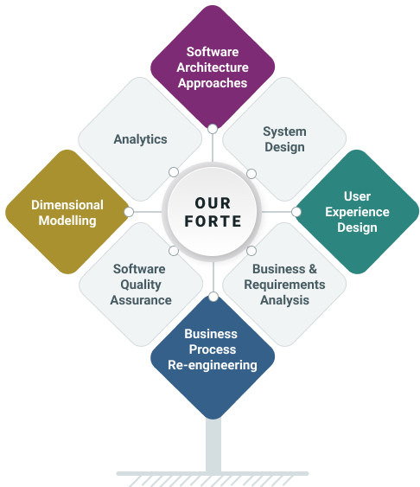
Argusoft has been in business for over 25 years and has successfully undertaken a range of large enterprise-grade projects with small, medium, to very large private, public and government organizations. Argusoft is a software solutions design consultancy that develops, deploys on-cloud/on-premises and grooms such enterprise-class software solutions. Most significantly, our solutions are incredibly protean, ensuring that the business needs are always quickly and easily aligned to the solution. We capitalize on our low-code framework to deliver fully customized solutions that are very stable, quick to configure and hence faster to deliver.

Argonauts (team argusoft!) are trained to think ‘design’ at every step. We architect, design, and code, always keeping our clients' business objectives in mind. We work as total partners, fully shouldering the responsibility of their business enabling software systems or, in the case of software product companies, as trusted technology partners of their core business offering.

Argusoft has successfully accomplished several significant SOA software development projects for Fortune 1000 US and India clients over the last dozen years. It plans to continue its focus on this activity as a turnkey software services provider. Argusoft’s forte is its solution design and technological prowess to build and deploy large enterprise-class software systems successfully. Several of these systems have also been developed and managed by Argusoft for several years. Argusoft has never been restricted by domains or verticals.

Why we do, what we do
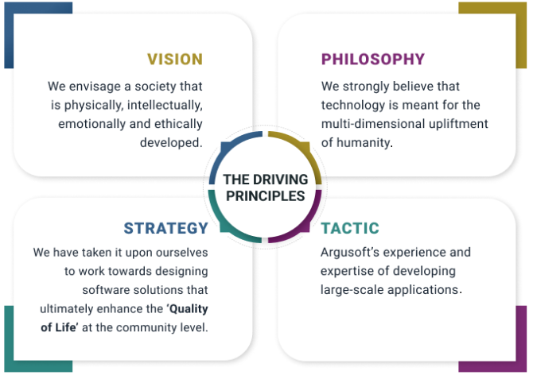

Registration Certificate and GST Certificate
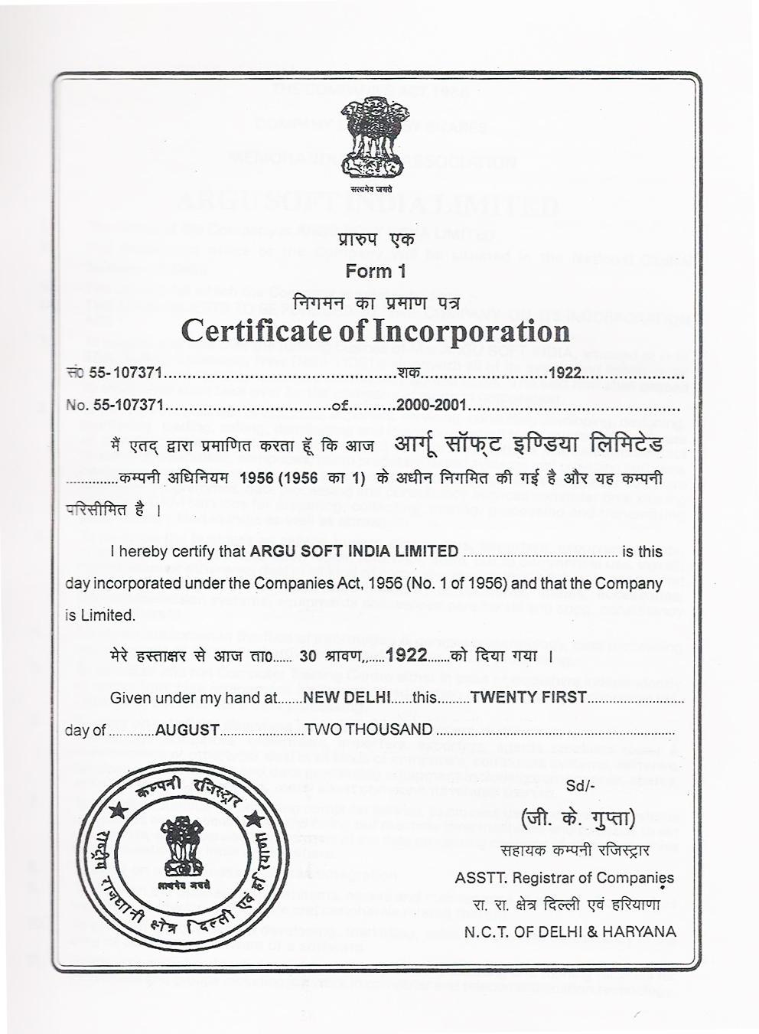

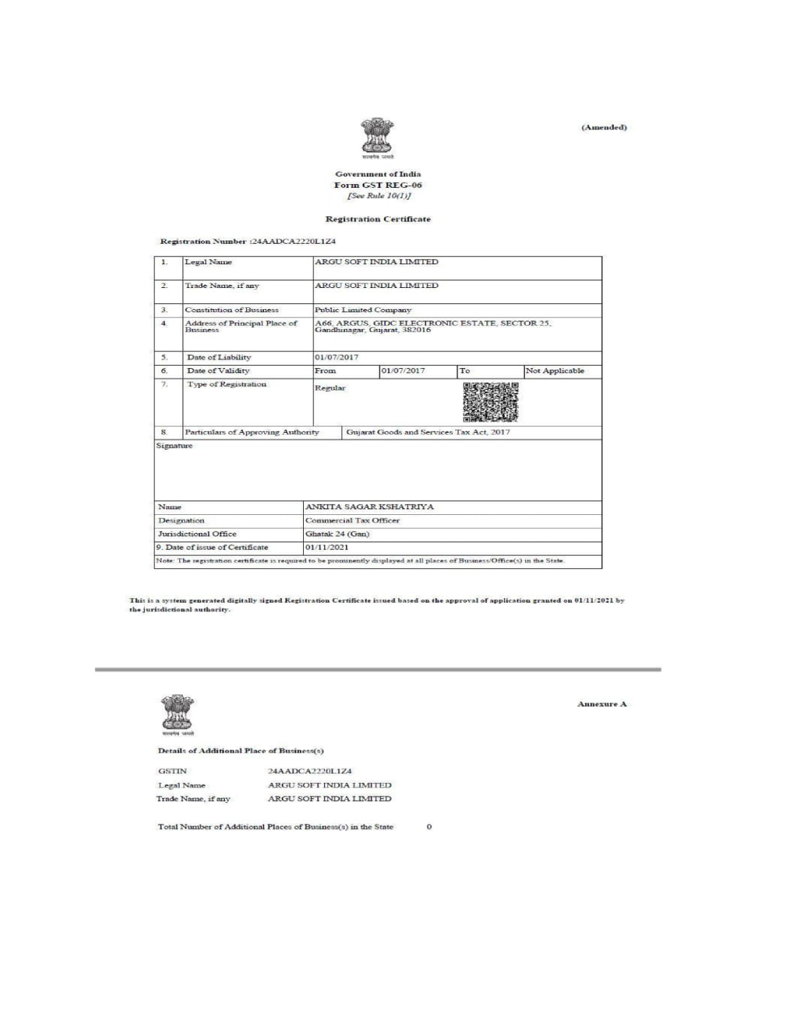

Geographical Presence
Argusoft has a global presence in terms of digital solution deliveries. It has designed and implemented solutions in over a dozen countries in five continents. Argusoft provides Consulting, Solution Design, Solution Architecture, Software Solution Development, Business Analysis, QA & Testing, Client Support, and Business Operations from its global delivery centre in India office. It has several partner offices in the US, Middle East, and Japan which are responsible for Business Development activities.
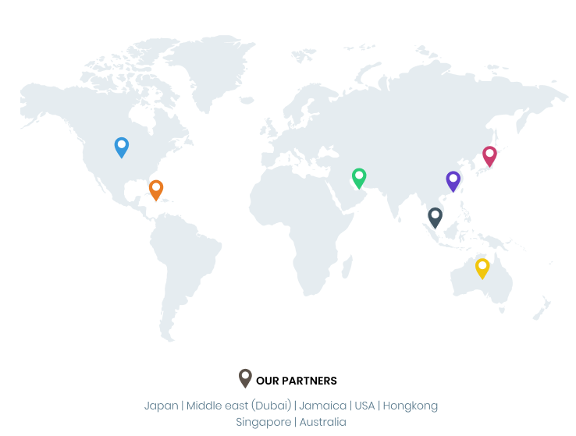
Argusoft - India Operations | Argusoft - US Operations
A-66, Sector 25, GIDC, Gandhinagar,  Gujarat 382016, India | 35463 Dumbarton Ct., Newark,  CA 94560, USA

Relevant Experience (Past Project References)
Argusoft brings extensive experience in designing, developing, and operationalizing large-scale, workflow-driven digital platforms for governments and global organizations. Our solutions have supported millions of beneficiaries and hundreds of thousands of frontline users, demonstrating our ability to deliver scalable, interoperable, and field-ready systems. The following projects are particularly relevant to the requirements of the MoWCA Integrated MIS.

Public Health Management Platform (PHMP / MEDplat-based Implementations)
Argusoft’s Public Health Management Platform (PHMP), powered by our open-source Digital Public Good MEDplat, has been deployed across multiple countries to support large-scale health and social service delivery programs. The platform is designed to manage end-to-end beneficiary lifecycles, integrate community and facility-level workflows, and enable real-time monitoring and decision-making.
PHMP supports key functionalities such as beneficiary registration, service delivery tracking, compliance monitoring, reporting dashboards, and integration with national systems. It is built on an API-first, modular architecture, enabling seamless interoperability with external systems such as identity registries, financial systems, and health information platforms.
A key strength of PHMP is its offline-first capability, allowing frontline workers to capture and sync data in low-connectivity environments—an essential requirement for field-driven programs. The platform also supports role-based access control, audit trails, and configurable workflows, ensuring transparency and accountability.
With deployments supporting millions of beneficiaries and large-scale government programs, PHMP demonstrates Argusoft’s ability to deliver scalable, configurable, and sustainable MIS platforms, directly aligned with the requirements of MoWCA.

TeCHO+ – Government of Gujarat, India
TeCHO+ is a large-scale, state-wide digital health platform developed and implemented by Argusoft for the Government of Gujarat. It digitizes maternal and child health services, including tracking of pregnancies, immunization, nutrition, and family planning services.
The system supports end-to-end beneficiary lifecycle management, from registration to service delivery and follow-up. It includes mobile applications for field workers with full offline capability, enabling them to operate effectively in remote areas. Automated alerts and reminders ensure timely service delivery, while GIS-enabled monitoring and dashboards provide real-time visibility to program managers at district and state levels.
TeCHO+ is integrated with multiple national systems, including civil registration and health platforms, demonstrating strong interoperability capabilities. The platform is currently used by 20,000+ frontline workers and supervisors, serving over 65 million beneficiaries .
Relevance to MoWCA MIS:
TeCHO+ showcases Argusoft’s ability to deliver large-scale, field-driven systems with strong beneficiary tracking, offline functionality, multi-level workflows, and real-time monitoring—key requirements for managing MCBP and VWB programs.

eKavach – National Health Mission, Uttar Pradesh, India
eKavach is a comprehensive primary healthcare management platform implemented for the Government of Uttar Pradesh, one of India’s largest states. The system supports maternal and child health, non-communicable disease management, family planning, and nutrition services, along with performance-based incentive management for frontline workers.
The platform handles complex, multi-level workflows, including beneficiary tracking, service delivery, verification, approvals, and financial disbursements. It integrates with financial systems for direct benefit transfers and supports large-scale incentive payments to health workers.
eKavach is used by approximately 250,000+ frontline workers and administrators, making it one of the largest implementations of its kind . It also features strong interoperability through integration with facility-based systems and national payment platforms.
Relevance to MoWCA MIS:
eKavach demonstrates Argusoft’s capability to manage complex workflows, financial disbursement processes, and large user bases, closely aligning with the MIS requirements for beneficiary payments, program compliance, and multi-level approvals in MoWCA programs.

EWARS – World Health Organization (Global Deployment)
Argusoft has partnered with the World Health Organization (WHO) to develop and deploy EWARS (Early Warning, Alert and Response System), a global platform used in over 40 countries for disease surveillance and outbreak response.
EWARS is designed for rapid deployment in challenging environments, featuring offline-first mobile applications, customizable reporting workflows, and GIS-based analytics. It enables real-time data collection, monitoring, and decision-making in resource-constrained settings, supporting both field teams and central authorities.
The system supports multi-level data validation, role-based access, and secure data handling, ensuring reliability and compliance with international standards.
Relevance to MoWCA MIS:
EWARS highlights Argusoft’s ability to deliver resilient, scalable, and secure systems in complex, low-resource environments, with strong emphasis on real-time monitoring, data integrity, and field usability—critical for nationwide MIS deployment.
Conclusion
Across these implementations, Argusoft has consistently demonstrated the ability to deliver large-scale, beneficiary-centric, and workflow-driven platforms that operate effectively in real-world conditions. Our experience in integrating systems, managing complex program logic, supporting field operations, and ensuring long-term sustainability makes us a strong fit for the successful implementation of the MoWCA Integrated MIS.

Technical Proposal / Methodology Proposed in the Proposal

Scope of Work - Our Understanding

Background
The Ministry of Women and Children Affairs (MoWCA) aims to implement an integrated Management Information System (MIS) to support the Mother and Child Benefit Programme (MCBP) and the Vulnerable Women Benefit (VWB) program.
As highlighted in the TOR, the current legacy MIS has limitations in scalability, integration, and functionality, leading to fragmented workflows and data silos across programs .
The proposed solution will establish a unified, scalable, and interoperable digital platform that enables end-to-end program management—from beneficiary enrollment to benefit disbursement, grievance handling, and monitoring.

Objectives of the RFP
Our understanding is that the key objectives of this engagement are to:
- Develop a centralized MIS platform supporting the full lifecycle of beneficiaries across MCBP and VWB.
- Enable end-to-end digitization and automation of program workflows.
- Ensure real-time data visibility through dashboards and reporting for informed decision-making.
- Facilitate interoperability with national systems (e.g., NID, health systems, G2P payment platforms).
- Strengthen transparency, auditability, and accountability through system-driven controls.
- Ensure data security, privacy compliance, and system sustainability with knowledge transfer to MoWCA.

Our Understanding of Tasks to be Done
We understand that the selected vendor will be responsible for delivering a turnkey MIS solution, including design, development, deployment, and maintenance. The key responsibilities include:
1. End-to-End MIS Implementation
- Design and develop an integrated MIS covering both MCBP and VWB programs.
- Ensure configurability to support program-specific rules and workflows within a unified system.
2. Beneficiary Lifecycle Management
- Enable digital application, verification, approval, and enrollment processes.
- Maintain comprehensive beneficiary profiles with lifecycle tracking and audit logs.
- Support program entry, continuation, and exit workflows.
3. Benefit Processing & Disbursement
- Automate benefit calculation and payment processing (cash and in-kind).
- Integrate with G2P platforms, iBAS++, and Mobile Financial Services (MFS).
- Enable payment tracking, reconciliation, and exception handling.
4. Program-Specific Modules
- Implement modules for:
  - Savings Management (VWB)
  - Food Distribution Management (VWB)
  - Training & Capacity Building
- Ensure linkage between program compliance and benefit eligibility.
5. Grievance Redress System (GRS)
- Provide a structured grievance management system with:
  - Ticketing, workflow routing, and escalation
  - SLA-based resolution tracking
  - Multi-channel grievance intake
6. Monitoring, Evaluation & Reporting
- Develop real-time dashboards and analytical reports.
- Enable data-driven decision-making through configurable MIS reports.
- Support data export and advanced analytics capabilities.
7. User Management & Access Control
- Implement Role-Based Access Control (RBAC) aligned with administrative hierarchy.
- Enable secure authentication mechanisms, including SSO readiness.
- Maintain comprehensive audit trails.
8. Interoperability & Integration
- Ensure API-based integration with:
  - National ID (NID) systems
  - Health systems (DGHS, DGFP)
  - Financial systems (iBAS++, G2P)
  - Other government registries
- Align with national interoperability frameworks (NDGIO, BeGA).
9. Security, Compliance & Data Protection
- Implement end-to-end data security, including encryption and access control.
- Ensure compliance with national data protection regulations and global standards.
- Conduct VAPT and security audits prior to go-live.
10. Mobile & Field Enablement
- Provide mobile application support for field-level operations.
- Enable offline data capture and synchronization for remote areas.
11. Training & Change Management
- Conduct comprehensive training programs for all user groups.
- Provide user manuals, SOPs, and training materials in relevant languages.
- Support adoption and transition from legacy systems.
12. Deployment & Post-Go-Live Support
- Deploy the solution at National Data Center (NDC)/cloud infrastructure.
- Perform data migration from legacy systems.
- Provide 12 months of maintenance and support, including:
  - Helpdesk and ticketing support
  - Bug fixes and minor enhancements
  - Performance monitoring and reporting

Key Deliverables
- Inception Report & System Requirement Specification (SRS)
- System Architecture & Design Documents
- Configured MIS Modules (Web & Mobile)
- API Integrations with External Systems
- Test Plans, Test Reports, and VAPT Certification
- User Manuals & Training Materials
- UAT Sign-off and Go-Live Report
- Maintenance & Support Reports
- Final Handover Documentation
Conclusion
In summary, we understand that this engagement requires the delivery of a robust, scalable, secure, and interoperable MIS platform that unifies multiple social protection programs under a single system. The solution must not only digitize operations but also enable data-driven governance, improved service delivery, and long-term sustainability for MoWCA.

Why Argusoft?
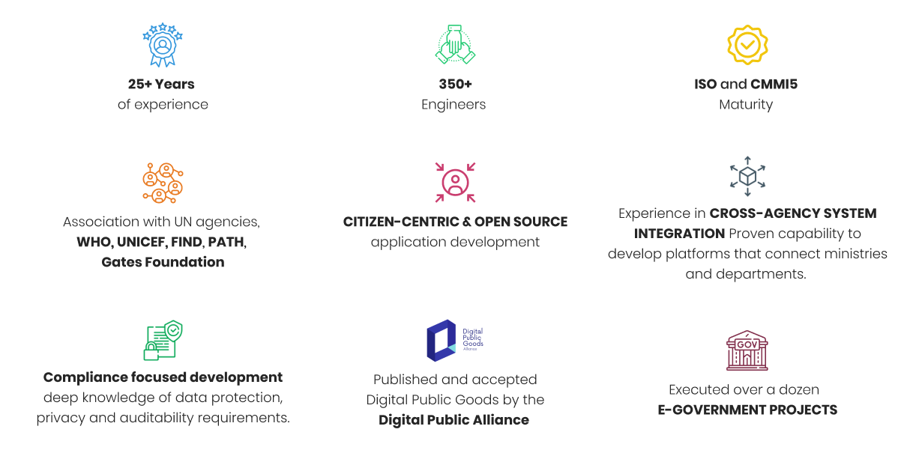
The MoWCA Integrated MIS initiative requires more than just a technology solution—it demands a partner who understands the realities of public sector program delivery, can design for scale and sustainability, and can successfully execute projects on the ground across multiple administrative levels. Argusoft is uniquely positioned to meet these requirements through its extensive experience in building and operationalizing large-scale, secure, and interoperable digital platforms for governments and international organizations.

Deep Experience in Government Digitization and Social Sector Platforms
Argusoft brings over two decades of experience in designing and implementing digital systems that transform complex, manual government processes into efficient, transparent, and auditable platforms. Our work spans public health, social protection, financial governance, and regulatory systems—domains that closely align with the requirements of the MoWCA MIS.
We have successfully delivered systems involving:
- Beneficiary lifecycle management
- Multi-level verification and approval workflows
- Integration with national registries and financial systems
- Role-based access, audit trails, and compliance mechanisms
This experience directly aligns with MoWCA’s need to manage complex program workflows across field, district, and national levels.

Proven Capability in Building Scalable, Mission-Critical Platforms
Argusoft has a strong track record of delivering platforms that operate reliably at scale. Our Digital Public Good platform, MEDplat, supports large user bases across multiple countries with real-time operations, offline functionality, and multi-agency coordination .
These capabilities—scalability, configurability, and resilience—are directly relevant to this RFP, ensuring that the MIS will perform effectively as beneficiary volumes grow and program needs evolve.

Strong Expertise in Workflow-Driven System Design
At the core of this RFP is the need to digitize and automate complex workflows. Argusoft has deep experience in building workflow-driven systems that manage multi-step processes, approvals, validations, and exception handling across multiple stakeholders .
Our solutions ensure that workflows are configurable, transparent, and aligned with program rules—enabling efficient and accountable service delivery.

Interoperability and Integration Expertise
The MIS requires seamless integration with national systems such as identity, health, and payment platforms. Argusoft specializes in API-driven architectures that enable secure and reliable data exchange across systems.
Our experience in integrating with diverse government and third-party systems ensures that the MIS will function as part of a connected ecosystem, eliminating data silos and improving operational efficiency.

Experience with Security, Compliance, and Global Standards
Argusoft follows a security-by-design approach, ensuring robust data protection, encryption, and access control mechanisms. Our experience working with global organizations such as WHO and other international agencies has required adherence to strict security and compliance standards, which we bring into every implementation.
This ensures that the MoWCA MIS will handle sensitive beneficiary data securely and responsibly.

User-Centric Design and Field-Level Practicality
We understand that the success of this MIS depends on its adoption by field-level users. Argusoft designs systems that are simple, intuitive, and practical for real-world use.
Our solutions include:
- Mobile-first and offline capabilities
- Simple, role-based interfaces
- Localization support
This ensures that the system is accessible and effective for all users—from field officers to policymakers.

Proven Ability to Successfully Deliver and Operationalize Systems on the Ground
A key strength of Argusoft is not just building systems, but successfully deploying and operationalizing them in real-world environments. We have extensive experience working closely with government departments, field staff, and partner organizations to ensure smooth implementation and adoption.
Our approach to on-ground delivery includes:
- Close coordination with stakeholders at national, district, and field levels
- Pilot implementations to validate system performance in real conditions
- Structured rollout strategies to ensure minimal disruption
- Hands-on training and capacity building for end users
- Continuous support during and after go-live to address real-time issues
In multiple country implementations, including large-scale public health and governance platforms, we have successfully navigated challenges such as limited connectivity, diverse user capabilities, and complex administrative structures. Our ability to combine technology delivery with strong on-ground execution ensures that systems are not only launched successfully but are also actively used and trusted by stakeholders.

Commitment to Capacity Building and Sustainability
Argusoft emphasizes long-term sustainability by empowering client teams through training, documentation, and knowledge transfer. We ensure that MoWCA teams are fully equipped to manage and evolve the system independently, reducing long-term dependency.

Proven Track Record with Global and Government Stakeholders
Argusoft has collaborated with leading global organizations such as WHO, the Bill & Melinda Gates Foundation, the Global Fund, PATH, and multiple governments . These engagements demonstrate our ability to work effectively in complex, multi-stakeholder environments and deliver impactful solutions.

Conclusion
In summary, Argusoft offers a strong combination of technical expertise, domain understanding, and proven on-ground delivery capability. Our ability to design, build, and successfully operationalize scalable and interoperable government platforms makes us a reliable partner for this initiative. We are committed to delivering a solution that is not only technically robust but also practical, sustainable, and impactful for MoWCA and its beneficiaries.

Approach
Argusoft’s approach to the MoWCA Integrated MIS is centered on delivering a solution that is not only technically robust but also practical, scalable, and effective in real-world program implementation. We recognize that this system will play a critical role in managing social protection programs that directly impact beneficiaries, and therefore, our focus is on building a platform that is reliable, easy to use, and adaptable to evolving program needs.
Rather than adopting a rigid, one-size-fits-all model, we propose a configurable, bespoke-enabled solution—leveraging our proven platforms and reusable components to accelerate delivery, while customizing key functionalities to align with the specific requirements of the MCBP and VWB programs. This ensures a balance between speed, flexibility, and long-term sustainability, while also enabling MoWCA to retain full ownership and control of the system.
Our approach is guided by a few key principles:
- User-first design: Ensuring the system is intuitive and accessible for field staff, administrators, and policymakers
- Configuration over customization: Allowing program rules and workflows to evolve without major redevelopment
- Interoperability by design: Enabling seamless integration with national systems such as NID, health platforms, and G2P/payment systems
- Security and reliability: Embedding data protection, auditability, and system resilience from the ground up
- Sustainability and ownership: Ensuring MoWCA teams can independently manage and evolve the system
Key Implementation Activities
To translate this approach into execution, Argusoft will undertake the following high-impact activities:
1. Collaborative Requirement Finalization
We will conduct structured consultations with MoWCA, DWA, and field-level stakeholders to validate requirements, understand current workflows, and identify practical challenges. This ensures that the system reflects real operational needs and policy requirements.
2. User-Centric Design and Prototyping
We will develop interactive prototypes and wireframes to visualize key modules such as beneficiary enrollment, payment processing, and grievance handling. Early validation through these prototypes helps ensure alignment and reduces rework.
3. Iterative Development with Continuous Feedback
Development will be carried out in phased, iterative cycles, with regular demonstrations to stakeholders. This allows for early feedback, faster issue resolution, and continuous alignment with expectations.
4. Integration and Interoperability Enablement
We will design and implement secure integrations with external systems (e.g., identity, health, and financial platforms), ensuring seamless data exchange and eliminating duplication.
5. Comprehensive Testing and Quality Assurance
A rigorous testing approach will be followed, covering:
- Functional and integration testing
- Performance and scalability testing
- Security testing (including VAPT)
- User Acceptance Testing (UAT)
This ensures that the system is stable, secure, and ready for production use.
6. Training, Change Management, and Rollout
We will support MoWCA through structured training programs, user manuals, and on-ground support during rollout. A phased deployment strategy (including pilot where needed) will ensure smooth adoption.
7. Post-Go-Live Support and Continuous Improvement
Following deployment, we will provide ongoing support, monitoring, and incremental enhancements to ensure system stability, performance, and responsiveness to evolving needs.
Delivery Team and Governance
Argusoft will deploy a dedicated, multidisciplinary team comprising:
- Project Manager (PMP-certified)
- Technical Architect and Tech Lead
- Frontend, Backend, and Mobile Developers
- QA and Security Specialists
- DevOps Engineers
- Business Analysts and Domain Experts
The team will work closely with MoWCA through a structured governance model, including regular review meetings, progress tracking, and risk management to ensure timely and high-quality delivery.

Methodology
Argusoft recognizes that any software development project's success depends on the methodology used as much as all the other components. In this regard, significant emphasis is laid on the methodology to be chosen based on the project's requirements and type.
At Argusoft, we have experience working with both waterfall and agile methodologies. For the proposed system, we plan to follow a hybrid approach. During the initial planning and design phases, we plan to follow a waterfall approach. Having the requirements at a fairly detailed level lends itself very well to building a clickable model. This will help all stakeholders have a 360-degree directional view. During the development stage, we plan to follow Agile. Two to four-week sprints will be defined, and the backlog will burn down.
The following diagram depicts the flow of actions to be carried out during lifecycle:
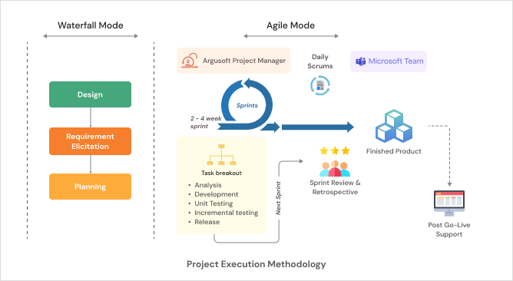

Functional Landscape Diagram
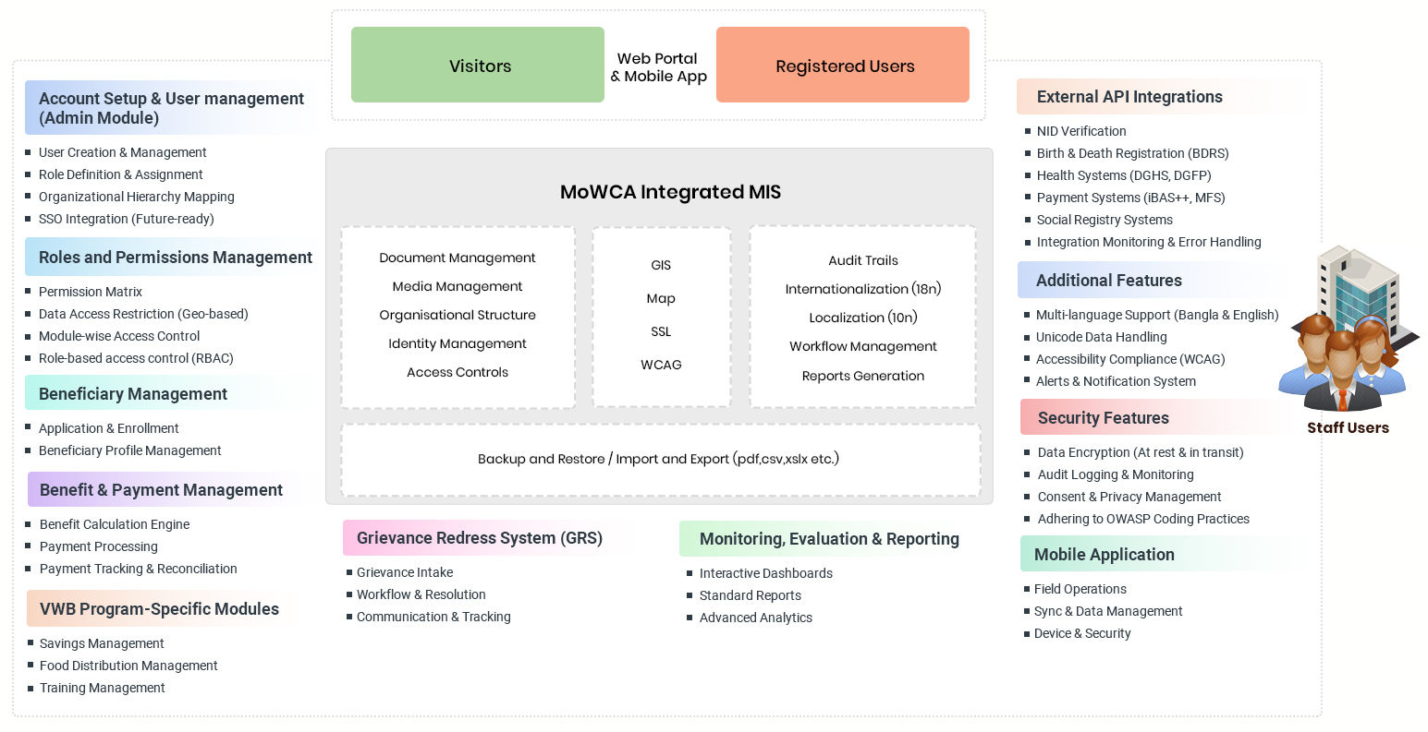

Proposed Solution
In response to the requirements outlined in the Terms of Reference, we propose a unified digital MIS solution comprising a responsive web application and a mobile application supported by a secure backend. The web application will serve as the primary platform for program administration, beneficiary management, payments, grievance handling, and monitoring, with role based access for users across Union, Upazila, District, and Ministry levels. The mobile application will support field level operations such as beneficiary enrollment, verification, grievance logging, and distribution tracking, with offline capability for low connectivity areas. A centralized API layer will ensure seamless integration and data flow across all modules and external systems such as NID, BDRS, health systems, and payment platforms. The solution will be hosted on a secure and scalable infrastructure, designed to support high availability, data security, and future expansion.
The web app and mobile will be developed to ensure optimal performance even when operating on slow or unreliable network connections. To achieve this, we plan to incorporate local as well server caching. By storing frequently accessed data in the server cache layer, we can significantly reduce the need for repeated database queries. We will utilize technologies such as IndexedDB or Web Storage or redis to store data on a cache layer for better performance. Additionally, strategies such as lazy loading and pre-fetching will be implemented to minimize the amount of data to be cached and improve performance even further. We also suggest maintaining a small sqlite DB in the mobile app to support the offline functioning of the app.
After a careful review of the scope of work and terms of reference provided in the RFP, we propose an n-tier architecture solution for this project. The first and most important highlight of this approach is the separation of service and UI layers, which means ease of maintenance and ease of extensibility.
This architecture pattern ensures that the application is capable of extensibility without compromising on performance and accuracy while ensuring a high level of ease of maintenance. The solution’s Service Oriented Architecture enables the creation of applications by combining loosely coupled and interoperable services. These services inter-operate based on a formal definition (or contract) that is independent of the underlying platform and programming language. The presentation tier itself has been modeled on the MVC architecture.
More specifically, the MVC pattern in this project is not only robust but best suited considering that the core process and business rules have been thought through and documented and hence can be built, modified or enhanced in the Business Layer without the need to change any of the other layers. In addition to this, the Proposed solutions use ORM (Object-Relational Mapping) in the Model to make the system database agnostic.
Architecture Diagram
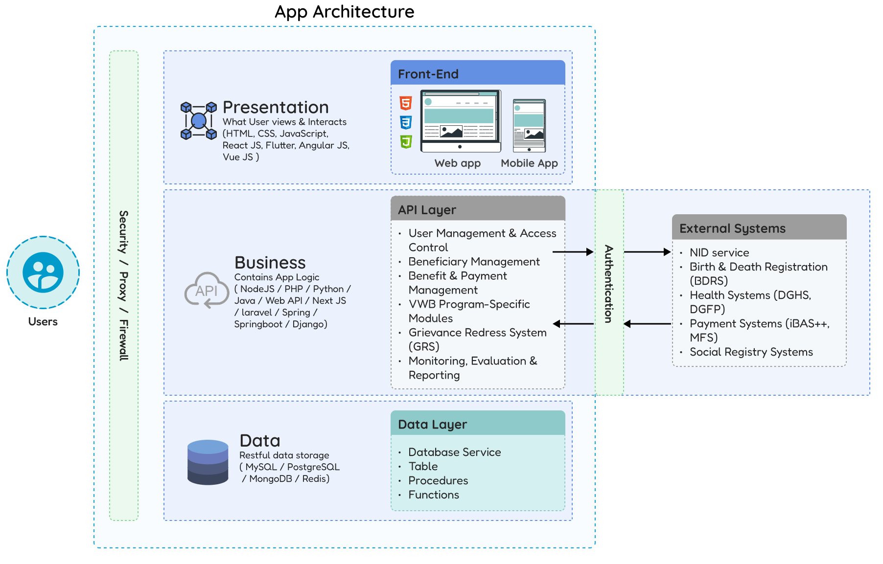

The app architecture will have the following layers:

Front-end (Presentation Layer/Tier)
The front-end, also known as the presentation layer, would handle the user interface and user experience for the MoWCA integrated MIS solution. It would consist of technologies like HTML, CSS and Javascript that can be rendered through a web browser on desktops and mobile devices.
The front-end tier in a single page application (SPA) typically follows Model-View-Controller (MVC) architecture, which separates the concerns of the application into three distinct components - the data (model), the user interface (view), and the logic that binds the two (controller).
- The Model represents the data and the business logic of the application. It can retrieve data from the server via an API or manage data entered by the user.
- The View represents the user interface of the application. It is responsible for displaying the data to the user and collecting input from the user.
- The Controller is the component that sits between the Model and the View. It is responsible for receiving user input, updating the Model based on that input, and updating the View to reflect any changes in the data.
In a SPA, the front-end tier communicates with the server via APIs to retrieve and update data. This allows the front-end to operate independently of the back-end, improving scalability and maintainability of the application.
Such separation of concerns would allow for more modular and maintainable code and makes it easier to update the user interface without impacting the rest of the application.

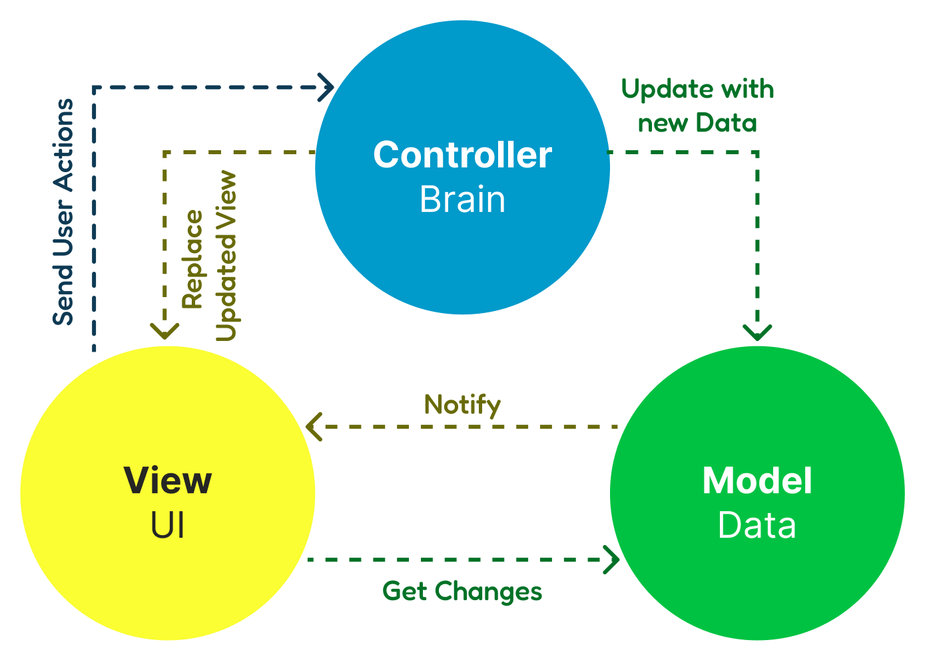

API - Application Programming Interface Layer/Tier
The API acts as a standard channel for the application to interact with the Business Logic & Rules. API Generally encompasses the Business Logic layer too, which is responsible for implementing the functionality required to support the business process.
The API Layer provides a reusable set of services that can be consumed by the front-end application. If required, the APIs can be used to exchange data with other external systems in an industry-standard manner. The API layer also provides help in decoupling the front-end and back-end layers of the application, allowing them to be developed and maintained independently. This means changes to one layer will not affect the other, allowing for more flexibility and scalability.

Data Access Layer
The data layer refers to the part of the application that deals with storing, retrieving and manipulating data. It abstracts the underlying data storage mechanism and provides a consistent way for the rest of the application to interact with the data. With abstraction, it automatically provides portability, where it is easier to port the application to a different data storage mechanism.
In the 3-tier architecture, the front-end tier is typically separate from the other two tiers (business logic and data) to allow for flexibility in design and implementation and to make it easier to update, maintain and modify components without impacting the other parts of the application. The front-end, API, and data tiers can be scaled independently, making it easier to handle increased user traffic or changes in system requirements.

Important Modules
We have thoroughly analyzed the requirement and gained an understanding of the project’s scope, objectives, and deliverables. In this section, we specify all the functional requirements that fall under the Scope of Work. Based on our understanding we propose the following modules.
- Account Setup & User management (Admin Module)
  - User Creation & Management
  - Role Definition & Assignment
  - Organizational Hierarchy Mapping
  - SSO Integration (Future-ready)
- Roles and Permissions Management
  - Permission Matrix
  - Data Access Restriction (Geo-based)
  - Module-wise Access Control
  - Role-based access control (RBAC)
- Beneficiary Management
  - Application & Enrollment
  - Beneficiary Profile Management
- Benefit & Payment Management
  - Benefit Calculation Engine
  - Payment Processing
  - Payment Tracking & Reconciliation
- VWB Program-Specific Modules
  - Savings Management
  - Food Distribution Management
  - Training Management
- Grievance Redress System (GRS)
  - Grievance Intake
  - Workflow & Resolution
  - Communication & Tracking
- Monitoring, Evaluation & Reporting
  - Interactive Dashboards
  - Standard Reports
  - Advanced Analytics
- External API Integrations
  - NID Verification
  - Birth & Death Registration (BDRS)
  - Health Systems (DGHS, DGFP)
  - Payment Systems (iBAS++, MFS)
  - Social Registry Systems
  - Integration Monitoring & Error Handling
- Additional Features
  - Multi-language Support (Bangla & English)
  - Unicode Data Handling
  - Accessibility Compliance (WCAG)
  - Alerts & Notification System
- Security Features
  - Data Encryption (At rest & in transit)
  - Audit Logging & Monitoring
  - Consent & Privacy Management
  - Adhering to OWASP Coding Practices
- Helpdesk & Support Module
  - Ticket Management
  - Resolution Workflow
  - Knowledge Base
- Mobile Application
  - Field Operations
  - Sync & Data Management
  - Device & Security

Administrative module, Roles and RBAC (Role-based access controls)
The administrative module will provide user registration and a secure login system that verifies the identity of the authorized personnel. User registration will require a unique email address along with a strong password that meets the required complexity requirements. Once a user is registered, they would be able to log in through the email and password.
For Password Storage, we would implement the technique based on hashing and salt. Hashing algorithms like SHA-256 will be used to generate a fixed-length hash value that cannot be reversed to reveal the original password. A salt value will be added to each password to prevent dictionary attacks, and make sure that two users with the same password do not generate the same hashed password.
RBAC (Role-Based Access Control) will be implemented to control access to different parts of the application based on user roles. The system will define roles aligned with program hierarchy (e.g., UDC Operator, Upazila Officer, District Officer, MoWCA Admin), each with a specific set of permissions. Access to specific modules and actions will be restricted to users with appropriate roles. In addition, users will be mapped to their respective geographic units, ensuring that data access is restricted based on location (e.g., Union/Upazila/District-level visibility).
Admin personnel can invite new users to the application via this module, or users can register themselves by visiting the registration page. This will trigger an email invitation that will include a link that will allow the recipient to create/configure a new account with the application. The link will use a one-time-use token that will expire after a certain amount of time or after it has been used.
The Logout process will ensure that the user’s session is terminated, thus preventing any unauthorized access to the web application. This process will also clear any sensitive data stored in the user’s browser.
To ensure security, we also recommend additional security measures like rate limiting, CAPTCHA, and Two-Factor Authentication (2FA). Rate limiting can be used to prevent brute force attacks on the login page, while CAPTCHA can be used to prevent automated attacks. 2FA can be used to add an extra layer of security to the login process.
Users can recover their passwords through the password recovery feature. The feature will allow users to enter their email addresses and get a password reset link sent to their email addresses. The password reset link will use a one-time-use token set to expire after a certain amount of time or after it has been used.
To support government ecosystem integration, the module will be designed to be compatible with Single Sign-On (SSO) mechanisms (e.g., SAML/OAuth) if required in future. Additionally, all user activities (login, data access, approvals, updates) will be logged to maintain a complete audit trail for monitoring and compliance.

Beneficiary Management
The Beneficiary Management Module will serve as the core foundation of the MIS, enabling end-to-end management of beneficiaries across both MCBP and VWB programs. The module will be designed as a unified yet configurable system to accommodate program-specific rules while maintaining a common data structure and workflow. It will cover the full lifecycle from application intake and verification to enrollment and ongoing profile management, ensuring transparency, traceability, and ease of use for field and administrative users.
The application and enrollment process will be implemented through an intuitive, form-driven interface accessible via both web and mobile platforms. The UI will follow a guided, step-by-step wizard approach to simplify data entry for users with varying levels of digital literacy. Each step will group related fields such as personal details, household information, socio-economic indicators, and program-specific eligibility criteria. Contextual validations and inline error messages will ensure data quality at the point of entry. For example, fields like NID number, date of birth, and mobile number will be validated in real time, with integration hooks to external systems (such as NID or birth registration databases) to verify authenticity where APIs are available.
To support assisted registration at Union Digital Centers or by field officers, the system will include a “Draft Save” and “Resume Application” feature, allowing partially completed applications to be revisited. For areas with limited connectivity, the mobile application will support offline data capture using local storage (e.g., SQLite) with a background synchronization engine to push data to the central server when connectivity is restored. Technologies such as Progressive Web Apps (PWA) or frameworks like React Native/Flutter can be considered to ensure a consistent cross-platform experience.
Once an application is submitted, the system will automatically run an eligibility screening engine based on configurable business rules. These rules will be parameterized (e.g., age range, number of children, marital status) and managed through an admin interface, allowing future policy updates without code changes. Applications that pass initial screening will be routed to a verification workflow, where field officers can review and validate information through a dedicated verification dashboard. This dashboard will present application details alongside checklists, document previews, and verification status indicators, enabling efficient field validation. The system will also allow geo-tagging and timestamping of verification activities, adding an additional layer of authenticity.
The approval workflow will follow a multi-level process aligned with administrative hierarchy. Role-based dashboards will display pending cases, prioritized using configurable criteria such as vulnerability scores or quotas. Decision-making screens will include comparison views, flags for inconsistencies, and audit history to support transparent selection. Once approved, the system will automatically generate a unique Beneficiary ID and transition the record into the enrolled state, triggering downstream processes such as payment eligibility.
The system will include a structured mechanism to manage rejected and waitlisted applicants, ensuring full transparency and traceability. All applications will be retained with clear status labels such as rejected or waitlisted, along with recorded reasons for the decision. The interface will allow users to filter and review these applications easily. Waitlisted applicants can be reconsidered and moved to approved status based on availability or updated criteria, with comparison views to support decision making. This approach avoids duplicate applications and ensures fairness in selection.
The Beneficiary Profile Management component will maintain a comprehensive, 360-degree digital profile for each beneficiary. The UI will present this as a consolidated profile page with tabbed sections for personal information, program details, payment history, grievances, training participation, and savings (for VWB). Authorized users will be able to initiate updates to specific fields, with configurable approval workflows for sensitive changes such as bank account details. All changes will be versioned and logged, ensuring a complete audit trail.
The Profile Update and Change Request workflow will allow controlled updates to beneficiary information. Instead of direct edits, users will submit change requests through a form interface, which will be routed for approval based on the type of update. Sensitive changes such as bank details will require additional validation. Review screens will show current and proposed values for clarity, and each request will be tracked with status, comments, and timestamps. Approved updates will reflect in the profile while maintaining a history for audit purposes.
Lifecycle event tracking will be an important aspect of this module. The system will allow users to record events such as childbirth, change in marital status, or migration, which may impact eligibility. These events will trigger rule-based alerts or re-evaluation workflows. For example, if a beneficiary exceeds the eligible child limit or remarries (in the case of VWB), the system can flag the record for review or initiate an exit process. This dynamic handling ensures that beneficiary data remains current and aligned with program policies.
Security and privacy will be embedded throughout the module. Access to beneficiary data will be strictly controlled through role-based and geo-based access policies, and sensitive information will be encrypted both in transit and at rest. The system will also ensure compliance with data protection standards by limiting data exposure and maintaining consent records where applicable.
The Document Management component will enable secure handling of all beneficiary documents. Users will be able to upload and view documents such as identity proofs and verification records through a simple interface with preview and validation features. Documents will be linked to beneficiary profiles and relevant workflows, allowing reviewers to verify and annotate them during processing. All documents will be securely stored in encrypted form to ensure data protection and compliance.
Overall, the Beneficiary Management Module will not only digitize the enrollment and management process but also introduce intelligence, automation, and accountability into the system. By combining user-friendly interfaces with robust backend processing and integration capabilities, the module will significantly improve efficiency, reduce manual errors, and provide a reliable foundation for program delivery and monitoring.

Benefit & Payment Management
The Benefit and Payment Management Module will be responsible for ensuring accurate, timely, and transparent disbursement of benefits to eligible beneficiaries under both programs. The design will focus on automation of calculations, strong validation controls, and seamless integration with external payment systems, while still providing users with clear visibility and control through intuitive interfaces.
The process will begin with a configurable Benefit Calculation Engine that determines eligibility and payable amounts for each beneficiary during a defined payment cycle. Program rules such as monthly allowance limits, duration caps, and conditional checks will be maintained through an administrative configuration screen so that policy updates can be applied without code changes. The user interface for administrators will allow easy adjustment of parameters such as payment frequency, benefit amount, and eligibility conditions. During each cycle, the system will automatically evaluate all active beneficiaries and generate a list of those eligible for payment. For MCBP, this includes enforcing rules related to child limits and duration, while also validating compliance conditions such as health visits if data is available. Any exceptions or rule violations will be clearly highlighted in the interface for review before finalization.
Once eligibility is determined, the module will support Payment Cycle Management, where authorized users can initiate and manage payment runs. A dedicated dashboard will display upcoming cycles, draft payment batches, and historical runs. Users will be able to review a Generated Payroll List, which presents beneficiaries grouped by payment method such as bank transfer or mobile wallet. The interface will include summary indicators such as total beneficiaries, total payable amount, and flagged exceptions.
The module will include a structured Payment Authorization Workflow to ensure proper validation and control before any disbursement is executed. Once a payment batch is generated, it will move through a maker checker process where one user prepares the batch and another authorized user reviews and approves it. The approval screen will present key details such as total amount, number of beneficiaries, and any flagged exceptions, allowing the reviewer to make an informed decision. Each approval or rejection action will be recorded with user details, timestamp, and comments to maintain a complete audit trail and ensure accountability.
Integration with external systems will be handled through secure APIs, enabling direct communication with platforms such as iBAS++ and mobile financial service providers. The system will generate standardized payment files or API payloads and transmit them securely. Technologies such as RESTful APIs with JSON format can be used for this integration, supported by frameworks.
After submission, the module will provide a Payment Tracking Dashboard where users can monitor transaction status in near real time. Each transaction will be tagged with a reference number and marked as successful, pending, or failed based on responses from external systems. Failed transactions will be clearly listed with reasons such as invalid account details or inactive wallets. The system will allow users to initiate a Reprocessing Workflow after correcting the underlying issue, ensuring that beneficiaries receive their due payments without manual intervention outside the system.
A strong focus will be placed on reconciliation through a dedicated Reconciliation and Reporting Interface. This will compare expected disbursements with actual payments confirmed by the external systems. Any discrepancies will be highlighted for further investigation. Users will be able to view detailed reports showing payment summaries, failure rates, and pending transactions. Export options in formats such as Excel or CSV will be provided for financial review and audit purposes. Open source libraries such as EPPlus or ClosedXML can be used for generating structured reports.
The module will also maintain a complete payment history within each beneficiary profile, allowing users to view past transactions, payment dates, and statuses in a simple tabular format. This improves transparency and helps field officers respond to beneficiary queries quickly. Search and filtering capabilities will enable users to locate transactions based on beneficiary name, location, or payment cycle.
Security and data integrity will be embedded throughout the module. All payment related data will be transmitted over secure channels using HTTPS, and sensitive information such as account details will be encrypted in storage. Role based access control will ensure that only authorized users can initiate, approve, or view payment data. Audit logs will capture all key actions including batch creation, approval, and transaction updates, supporting compliance and traceability.
In summary, the Benefit and Payment Management Module will streamline the entire disbursement process by combining automated rule based calculations, controlled approval workflows, and real time tracking. By integrating tightly with external financial systems, the module will significantly improve efficiency, reduce errors, and ensure that benefits reach the intended recipients in a timely and accountable manner.

VWB Program-Specific Modules
The VWB Program Specific Modules will be designed to address the distinct operational needs of the program while remaining tightly integrated with the overall beneficiary management system. These modules will ensure that all activities related to savings, food distribution, and training are systematically recorded, monitored, and linked to each beneficiary’s journey. The goal is to provide both operational efficiency for field teams and clear visibility for administrators into program performance and beneficiary progress.
Savings Management
This module will act as a structured financial tracking system for beneficiary contributions. Each beneficiary profile will include a dedicated Savings Ledger View that presents a chronological record of expected versus actual deposits, along with a running balance.
The interface will allow field officers or authorized users to record deposits through a simple data entry form that includes validations for amount, date, and contribution frequency. To improve usability, the form can include prefilled expected amounts based on program rules, reducing manual input errors. The system will also support bulk data entry through structured upload templates, which can be processed using libraries such as ClosedXML for Excel handling. For areas where integration with financial institutions is feasible, the design can accommodate import of transaction data to automatically reconcile deposits.
A Savings Compliance Indicator will visually highlight whether a beneficiary is on track, delayed, or non compliant, using color coded signals within the interface. In addition, a Savings Progress Tracker can provide a graphical representation of cumulative savings against the required threshold, helping both administrators and beneficiaries understand progress toward program completion.
A Savings Summary Dashboard will allow administrators to monitor trends across regions, identify beneficiaries who are consistently missing contributions, and take corrective actions. Alerts and notifications can be triggered for missed deposits, ensuring timely follow up. All transactions will be logged with timestamps and user details to maintain accountability and support audit requirements.
Food Distribution Management
This module will facilitate end to end planning and tracking of in kind benefit delivery. Administrators will use a Distribution Planning Interface to define distribution cycles, allocate quantities, and assign beneficiaries to specific distribution points. The system will automatically generate a Beneficiary Distribution List for each cycle, which can be accessed digitally or exported for field use. This list will include essential details such as beneficiary identity, allocated quantity, and verification reference.
During the distribution process, field staff will interact with a Distribution Execution Screen that allows quick marking of collection status. The interface will be optimized for ease of use in field conditions, with simple action buttons to mark collected, not collected, or partially collected. Where required, additional fields will capture remarks or special conditions such as proxy collection. The mobile interface can support offline data capture with later synchronization, ensuring continuity in low connectivity environments. A Real Time Distribution Tracker will provide administrators with visibility into ongoing distribution activities, showing key metrics such as total allocated, collected, pending, and missed distributions.
Post distribution, the system will generate a Distribution Reconciliation View that compares planned versus actual delivery. Any discrepancies will be flagged for review, allowing supervisors to investigate issues such as leakage or operational delays. Over time, historical data will support analysis of distribution efficiency and beneficiary participation patterns. This component ensures transparency and strengthens accountability in the delivery of physical benefits.
Training Management
The Training Management component will support the planning, execution, and monitoring of capacity building activities aimed at empowering beneficiaries. Administrators will be able to create training sessions through a Training Scheduler Interface, where details such as training type, topic, trainer, venue, and schedule are defined. The system will allow flexible participant selection, either by manually selecting beneficiaries or by applying filters such as location or eligibility criteria. Once sessions are created, beneficiaries will be notified through integrated communication channels where applicable.
For session execution, trainers or field staff will use an Attendance Capture Screen that allows them to record participation quickly. The interface can support features such as bulk marking of attendance and offline functionality for remote areas. Training materials can be uploaded and managed through a centralized repository, enabling easy access to content such as guides, videos, or presentations. This ensures consistency in training delivery across locations.
A Training Monitoring Dashboard will provide insights into participation rates, completion status, and coverage across regions. Each beneficiary profile will display training history, including sessions attended, completion status, and any certifications achieved. The system can also include a simple feedback mechanism where participants can provide input on training quality, which can be analyzed to improve future sessions. Alerts can be configured for beneficiaries who have missed mandatory training sessions, ensuring better compliance with program objectives.
Across all these components, the system will maintain strong integration with the beneficiary profile to provide a unified view of savings, distribution, and training activities. Users will be able to navigate seamlessly between these aspects, gaining a comprehensive understanding of each beneficiary’s progress.

Grievance Redress System (GRS)
The Grievance Redress System module will provide a structured and transparent mechanism for beneficiaries and stakeholders to raise, track, and resolve issues related to program services. The design will focus on accessibility, timely resolution, and full traceability of each grievance throughout its lifecycle. The module will be tightly integrated with beneficiary records so that complaints can be linked to specific individuals, payments, distributions, or services, enabling faster and more informed resolution.
Grievances can be registered through multiple channels including web interface, mobile application, and assisted entry by field staff. The system will provide a simple Grievance Registration Form where users can capture details such as grievance category, description, related beneficiary, and supporting documents if required. To improve usability, the interface can include predefined categories and subcategories that help in proper classification and routing. Upon submission, the system will automatically generate a unique tracking number and display a confirmation screen with status details. This tracking number can also be shared through SMS or other communication channels to allow beneficiaries to follow up easily.
Once registered, each grievance will enter a configurable workflow managed through a Grievance Management Dashboard. This dashboard will be role specific and will display pending, in progress, and resolved cases along with priority indicators. Cases will be automatically routed to the appropriate officer or department based on category, location, and predefined rules. The system will support assignment and reassignment of cases, ensuring flexibility in handling workloads. A detailed case view will allow users to review grievance information, access linked beneficiary data, and record actions taken. Status updates such as accepted, under review, resolved, or closed will be clearly visible, providing transparency at every stage.
To ensure timely resolution, the module will incorporate a Service Level Agreement feature where each grievance is associated with a defined resolution timeframe. The system will monitor deadlines and trigger alerts or escalations if cases remain unresolved beyond the defined limits. Escalation rules can be configured to automatically route cases to higher officers, ensuring accountability and adherence to service standards. Users will also be able to add comments and upload supporting evidence during the resolution process, creating a complete case history.
Communication will be a key aspect of the module. The system will include a Notification Engine that sends updates to beneficiaries and staff at important stages such as registration, assignment, and resolution. Beneficiaries will be able to check the status of their grievances through a simple tracking interface by entering their reference number. For internal users, notifications will appear within the system dashboard as well as through email or SMS, depending on configuration.
From a usability perspective, the module will provide filtering and search capabilities to help users quickly locate cases based on criteria such as status, category, location, or date. Summary views and simple charts can present trends such as number of grievances received, resolution rates, and common issue types, helping administrators identify systemic problems. Libraries such as Chart.js can be used to present these insights in a clear and interactive manner.
All grievance activities will be logged to maintain a complete audit trail, capturing user actions, timestamps, and status changes. Access to sensitive cases can be restricted based on roles to ensure confidentiality where required. Documents and attachments will be securely stored and linked to each case for easy reference during review.

Monitoring, Evaluation & Reporting
The Monitoring, Evaluation and Reporting Module will provide a comprehensive layer for tracking program performance, measuring outcomes, and enabling data driven decision making across MCBP and VWB initiatives. The module will be designed to consolidate data from all core components such as beneficiary management, payments, savings, training, and grievance systems into a unified analytical view. The focus will be on presenting accurate, real time insights through intuitive interfaces that can be easily used by both operational staff and senior decision makers.
At the core of the module will be a dynamic Dashboard Interface that presents key performance indicators in a clear and interactive format. Users will be able to view metrics such as total beneficiaries enrolled, active versus inactive cases, payment disbursement status, savings compliance, training participation, and grievance resolution rates. The dashboard will support filtering by geography, time period, and program type, allowing users to drill down from national level summaries to district or union level details. Visual elements such as charts, maps, and summary cards will make it easier to interpret trends and identify areas requiring attention. Libraries such as Chart.js or Apache ECharts can be used to build responsive and visually rich dashboards.
The module will include a robust Standard Reporting Interface where users can generate predefined reports aligned with program and administrative requirements. These reports will cover areas such as beneficiary enrollment, payment history, savings performance, training coverage, and grievance statistics. The interface will allow users to select parameters such as date range, location, and program type before generating reports. Outputs can be viewed on screen or exported in formats such as Excel, CSV, or PDF using libraries like ClosedXML or iText. This ensures that reports can be easily shared with stakeholders or used for official submissions.
For more advanced needs, the system will provide an Ad Hoc Report Builder that allows users to create custom reports without technical expertise. Through a simple interface, users can select data fields, define filters, and choose aggregation methods to generate tailored outputs. This feature will empower program managers to explore data and answer specific questions without relying on developers. To support efficient querying and performance at scale, the system can leverage optimized database indexing and caching mechanisms, with optional integration of tools like Elasticsearch for faster data retrieval.
The Monitoring, Evaluation and Reporting Module will transform operational data into meaningful insights by combining interactive dashboards, flexible reporting tools, and evaluation mechanisms. This will enable stakeholders to monitor progress effectively, identify gaps, and make informed decisions to improve program outcomes.

External API Integrations
The Integration and Interoperability will enable seamless data exchange between the MIS and key government and external systems, ensuring accuracy, reducing manual effort, and improving service delivery. The module will be designed around a secure API driven approach, allowing the system to communicate with external platforms in real time or through scheduled data synchronization. A centralized Integration Management Interface will allow administrators to configure endpoints, authentication credentials, and data mapping rules, ensuring flexibility as external systems evolve.
For identity validation, the system will integrate with national identity services through a NID Verification Service. During beneficiary registration or update, the system will send verification requests using secure APIs and retrieve validated identity details such as name, date of birth, and status. The user interface will display verification results instantly, highlighting matches or discrepancies to support decision making. This reduces duplication and ensures authenticity of beneficiary records.
Integration with the Birth and Death Registration System will support automated validation of life events through a BDRS Verification Interface. This will allow the system to confirm birth records for eligibility checks and detect death records to trigger appropriate actions such as benefit suspension. The verification results will be linked directly to beneficiary profiles, ensuring that eligibility decisions are always based on the latest available data.
The module will also support integration with health systems such as DGHS and DGFP through a Health Data Exchange Layer. This will enable retrieval of relevant health related compliance data where applicable, such as service utilization indicators. The interface will present this information within beneficiary records, allowing program administrators to assess compliance conditions without requiring manual data collection.
For financial transactions, the system will integrate with payment platforms through a Payment Integration Gateway. This will facilitate secure communication with systems such as iBAS++ and mobile financial service providers. The gateway will handle generation and transmission of payment instructions, as well as receipt of transaction status updates. Data will be exchanged using standardized formats such as JSON over secure channels, ensuring compatibility and reliability. This integration will support automated payment processing while maintaining full traceability of transactions.
The system will also connect with social registry platforms through a Social Registry Integration Interface to retrieve or validate beneficiary data. This will help in cross checking eligibility, avoiding duplication, and leveraging existing government data sources. The interface will allow controlled data exchange based on defined protocols, ensuring that only relevant information is accessed and used.
To ensure reliability, the module will include a comprehensive Integration Monitoring Dashboard that provides visibility into all data exchange activities. Administrators will be able to view the status of API calls, data synchronization jobs, and transaction outcomes in real time. Any failures or delays will be highlighted with detailed error messages. An Error Handling Mechanism will capture and log all integration issues, enabling retry processes and manual intervention where required. Notifications can be triggered for critical failures, ensuring that issues are addressed promptly.
Security will be a key consideration throughout the module, with all integrations using secure authentication methods such as API keys or token based access. Data will be encrypted during transmission and sensitive information will be handled in compliance with government standards.

Additional Features
The Localization and Accessibility will ensure that the system is inclusive, user friendly, and accessible to a diverse range of users across different regions.
The application will support both Bangla and English through a seamless Language Toggle Feature available across web and mobile interfaces. Users will be able to switch languages at any point, with all labels, forms, messages, and notifications dynamically updated without requiring a page reload. The design will follow a resource based approach where all text content is externalized into language files, making it easy to manage translations and extend support for additional languages in the future. Technologies such as i18next for web applications or built in localization support in frameworks like React Native and Flutter can be used to implement this efficiently.
To ensure accurate representation of local language data, the system will fully support Unicode Data Handling across all layers including database, application, and user interface. This will allow storage and display of Bangla characters without distortion or data loss. Databases such as PostgreSQL with UTF 8 encoding will be used to ensure compatibility, while input fields will be validated to handle multilingual data correctly. Search and reporting features will also be optimized to work seamlessly with Unicode text, ensuring consistent user experience.
Accessibility will be addressed in line with WCAG compliance standards, ensuring that the application is usable by individuals with varying abilities. The user interface will incorporate features such as proper color contrast, readable font sizes, and keyboard navigation support. Form elements will include clear labels and assistive text to support screen readers, and interactive components will follow accessible design patterns. Frontend libraries and guidelines such as ARIA standards can be used to enhance accessibility. These measures will ensure that the system is not only functionally robust but also inclusive and compliant with modern accessibility expectations.

Security Features
The Security and Compliance practices will ensure that the system adheres to strong data protection standards while maintaining trust, accountability, and regulatory alignment. The design will embed security practices across all layers of the application so that sensitive beneficiary and program data remains protected throughout its lifecycle.
Data protection will be implemented through robust Encryption Mechanisms for both data at rest and data in transit. All communication between client applications and servers will be secured using HTTPS with TLS protocols, ensuring that data cannot be intercepted during transmission. For data stored in databases and document repositories, encryption standards such as AES will be applied to sensitive fields like personal identifiers, bank details, and contact information. Secure key management practices will be followed, with encryption keys stored and managed separately using controlled access. This approach ensures that even in the event of unauthorized access, the underlying data remains protected.
To ensure accountability and traceability, the system will implement a comprehensive Audit Logging and Monitoring Framework. Every critical user action such as login attempts, data creation, updates, approvals, and payment processing will be recorded with details including user identity, timestamp, and activity description. A centralized Audit Log Viewer will allow authorized administrators to review system activities through searchable and filterable views. Monitoring tools can be integrated to track system performance and detect unusual behavior patterns. Technologies such as the ELK stack can be used to aggregate and visualize logs, enabling proactive identification of issues and supporting compliance audits.
The module will also include a structured Consent and Privacy Management Interface to ensure that beneficiary data is handled in accordance with privacy requirements. During data collection, users will be presented with clear consent statements outlining how their data will be used. The system will record consent status along with timestamps and allow updates or withdrawal where applicable. Access to sensitive data will be governed by role based controls, ensuring that only authorized users can view or modify information. This ensures transparency and builds trust with beneficiaries while aligning with data protection principles.
To safeguard the application from security threats, the system will follow best practices aligned with OWASP compliance standards. Input validation, output encoding, and secure session management will be implemented to prevent common vulnerabilities such as injection attacks and cross site scripting. Additional protections such as rate limiting, secure authentication mechanisms, and regular security testing will be incorporated into the development lifecycle. Open source tools such as OWASP ZAP can be used for vulnerability scanning and continuous security assessment.

Data Governance Framework and Data Protection Impact Assessment (DPIA)
Argusoft will develop and implement a comprehensive Data Governance Framework and conduct a formal Data Protection Impact Assessment (DPIA) as part of the project deliverables, in alignment with TOR requirements.
The Data Governance Framework will define:
- Data ownership, stewardship, and access roles
- Data lifecycle policies covering collection, validation, storage, sharing, archival, and deletion
- Data quality standards and validation mechanisms
- Data access control and sharing protocols
- Audit and compliance mechanisms
The DPIA will include:
- Identification and assessment of risks associated with personal data processing
- Evaluation of potential impacts on beneficiary privacy
- Definition of mitigation strategies and safeguards
- Alignment with national data protection regulations and international best practices
Both the Data Governance Framework and DPIA will be delivered as formal, standalone documents and will be updated as required during the system lifecycle.

Helpdesk & Support Module
We assume that an existing or third party support system will be available for Helpdesk & Support activities. Based on this, the Helpdesk and Support Module will be designed as a lightweight integration layer within the MIS, integrating with the external system rather than developing a standalone solution. The objective is to provide users with a seamless way to log issues and track their status without leaving the MIS environment. This will be achieved through secure API based integration with the external helpdesk platform.
Within the MIS interface, users will have access to a simple Raise Support Ticket screen where they can submit issues by providing details such as category, description, and optional attachments. The form will be designed to be intuitive and aligned with the external system’s structure to ensure smooth data mapping. Once submitted, the request will be sent to the integrated helpdesk system through its APIs, and a ticket reference number will be returned and displayed to the user.
Users will also be able to track their requests through a Ticket Status View, which will fetch real time updates from the external system. This view will display current status, recent updates, and resolution details in a clean and readable format. The MIS will act as a unified access point, while all advanced functionalities such as ticket assignment, escalation, and resolution workflows will continue to be handled within the external helpdesk platform.
From a technical perspective, REST based APIs will be used for integration, with secure authentication mechanisms such as API keys or token based access.

Mobile Application
The Mobile Application will be designed to support field level operations by providing a simple, reliable, and efficient interface for data collection, verification, and service delivery in both connected and low connectivity environments. The application will primarily be used by field officers, UDC operators, and program staff to perform tasks such as beneficiary enrollment, verification, grievance registration, training attendance, and distribution tracking. The design will focus on ease of use, minimal data entry effort, and strong offline capability to ensure smooth operation in remote areas.
The application will provide a guided user experience through a Task Based Home Screen, where users can quickly access key functions such as new application entry, pending verifications, grievance logging, and distribution activities. Each function will be presented as a clear workflow with step by step screens, reducing the learning curve for field users. For beneficiary enrollment and updates, the mobile interface will replicate the structured forms used in the web system, with features such as auto validation, dropdown selections for location hierarchy, and document capture using the device camera.
A critical feature of the mobile module will be its offline capability. The application will include an Offline Data Capture Engine that allows users to enter and store data locally on the device when internet connectivity is unavailable. This data will be securely stored using local databases such as SQLite. Once connectivity is restored, a Background Sync Service will automatically upload pending records to the central server. The synchronization process will include conflict detection and resolution logic to ensure data consistency, especially in cases where records may have been updated from multiple sources. For field verification activities, the application will provide a Verification Interface where users can review submitted applications, validate details, and capture additional information such as geo location and timestamps. This will help ensure authenticity and improve data reliability.
The mobile application will also support operational tasks such as grievance registration and training attendance. A Quick Grievance Entry Screen will allow field staff to log complaints on behalf of beneficiaries, with minimal required inputs and optional document attachments. Similarly, a Training Attendance Screen will allow trainers to mark participation using simple selection options, making it easy to use even in group settings. For distribution activities, the application can include a Distribution Tracking Screen where field users can mark whether beneficiaries have received their entitlements, ensuring real time or near real time updates.
From a technology perspective, the application can be developed using cross platform frameworks such as Flutter or React Native to ensure consistency across Android devices while reducing development effort. These frameworks provide strong community support and allow integration with device features such as camera, storage, and location services. For offline data handling, libraries that support local storage and synchronization can be used to ensure reliable performance.
Security will be embedded within the application through features such as secure login, token based authentication, and encrypted local storage for sensitive data. A Device Binding Mechanism can be implemented to restrict access to authorized devices, adding an extra layer of protection. Session management will ensure that inactive sessions are automatically closed, reducing the risk of unauthorized access.

Proposed Tech Stack
At Argusoft, we take a technology-agnostic approach when selecting tools and platforms for application development. We recognize that each technology has its own strengths, and our goal is always to choose the most appropriate tools that align with the solution’s objectives, performance requirements, and long-term maintainability. Our focus is on building robust, secure, and scalable systems using well-supported technologies, while ensuring the architecture remains modular and adaptable.
Below is the recommended technology stack for this project, selected specifically to meet the requirements outlined in the Terms of Reference, with an emphasis on performance, security, cross-platform consistency, and ease of future enhancement:
Frontend Framework
- React JS / Vue.JS / Angular (Web Portal)
A component-driven, declarative framework used for building fast, interactive, and scalable user interfaces. Ideal for administrative dashboards, real-time content management, and role-based access workflows.
Mobile Application Framework
- React Native (Android Mobile App)
A cross-platform mobile development framework that allows building native-like apps using a shared codebase. Suitable for health-related apps requiring consistent behavior across devices and responsive performance under varying connectivity conditions.
Backend Technologies
- Java / Node.js / Python / PHP
These technologies support RESTful APIs, robust user management, and content workflows. However selection will depend on the final hosting environment and integration requirements, but both offer strong community support and security frameworks.
Database Engine
- MySQL / PostgreSQL
Widely adopted open-source relational databases with support for complex queries, indexing, and structured data storage ideal for storing user profiles, feedback, content metadata, and audit logs.
Styling Technologies and Visualization Libraries
- HTML5, CSS3, Material UI - for responsive layouts and consistent UI
- Chart.js / D3.js - for visualizing surveillance trends and performance analytics in admin dashboards
Platform
- Ubuntu (Linux-based platform)
A stable and secure environment for deploying both frontend and backend components. Compatible with modern cloud infrastructure or self-hosted server configurations.
Security & API Layer
- HTTPS, OAuth2/JWT for authentication, role-based access controls, and secure REST API endpoints will be implemented to ensure protection of sensitive data and alignment with public health system standards.
This stack ensures consistency between the mobile and web layers, supports maintainability, and provides a solid foundation for CARPHA’s future digital evolution. Each technology is selected based on industry best practices, ToR alignment, and our prior experience delivering large-scale, multi-platform public sector solutions.

Hosting
As per our TOR document, we understand that BCC’s National Data Center or MoWCA will provide the necessary hosting infrastructure for Development/QA, UAT/Staging and Production environments and the necessary cloud Resources to support the application. We shall set up a process for maintenance of the integrated MIS software including backup and restoration policy, risk mitigation plan, security vulnerability check procedure etc.
With the hosting team, we would also discuss the deployment strategy. While developing a solution of this stature, proper continuous integration and continuous deployment environments must be created and exploited. We propose to use the below CI/CD implementation. We would be happy to discuss more on this and make changes if needed.
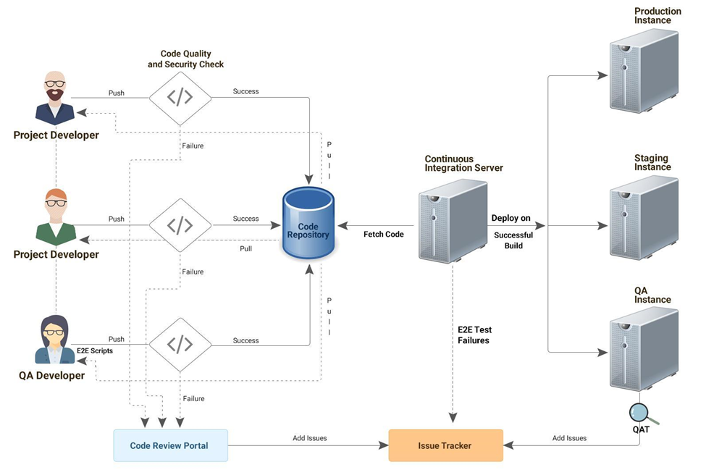

Proposed Work Plan
Our proposed work plan is built on Argusoft’s extensive experience in delivering large-scale government MIS and digital platforms. It is designed to align closely with the phased implementation approach outlined in the TOR, while remaining flexible to incorporate stakeholder inputs and evolving program needs.
We adopt a hybrid, adaptive approach, combining structured planning with iterative development and continuous stakeholder engagement. In parallel with phase-wise execution, we will prepare and continuously refine key project plans including:
- Project Management Plan
- System Development & Release Plan
- Integration & Data Migration Plan
- Testing & Quality Assurance Plan
- Training & Capacity Building Plan
- Deployment & Go-Live Plan
- Support & Maintenance Plan
This ensures that the project remains aligned, responsive, and delivery-focused throughout its lifecycle.

Phase 1: Inception, Requirement Finalization & Detailed Planning (Month 1)
Key Activities
- Project Kickoff: Conduct kickoff meetings with MoWCA, DWA, and key stakeholders to align on objectives, timelines, governance, and communication protocols.
- Stakeholder Consultations: Engage with stakeholders across national, district, and field levels to validate requirements and understand operational workflows.
- Process Mapping: Document current (“as-is”) and proposed (“to-be”) workflows for MCBP and VWB programs.
- Requirement Finalization: Refine and consolidate functional, technical, and integration requirements.
- Backlog Creation: Break down requirements into epics, user stories, and acceptance criteria.
- Risk & Planning: Define project plan, milestones, risk mitigation strategy, and resource allocation.
Deliverables
- Inception Report & Detailed Project Plan
- System Requirements Specification (SRS)
- Process Maps & Workflow Diagrams
- Product Backlog (Epics & User Stories)

Phase 2: System Design, Architecture & Prototyping (Month 2)
Key Activities
- Architecture Design: Define scalable, secure, and interoperable system architecture aligned with national standards.
- Database & Integration Design: Design data models and define integration approach with external systems (NID, health systems, G2P, etc.).
- Technology Stack Finalization: Finalize tools and frameworks in consultation with MoWCA.
- UI/UX Design & Prototyping: Develop clickable prototypes and wireframes for key modules (enrollment, payments, GRS, dashboards).
- Environment Setup: Establish development, testing, and staging environments; coordinate with hosting infrastructure.
Deliverables
- System Architecture & Design Document
- Database Schema & Integration Blueprint
- Clickable Prototype (UI/UX Designs)
- Environment Setup (Dev/Test/Staging)
- Design Sign-off from MoWCA

Phase 3: Development & Integration (Months 3–4)
Key Activities
- Agile Development: Execute development in 2–3 week sprints with regular demonstrations.
- Module Development: Build core MIS modules including:
  - Beneficiary Enrollment & Profile Management
  - Benefit Calculation & Payment Management
  - Savings, Food Distribution, and Training Modules
  - Grievance Redress System
  - Monitoring & Reporting Dashboards
- Integration Development: Implement APIs and connectors for external systems.
- Continuous Testing: Perform unit testing, integration testing, and code reviews during development.
- Progress Reviews: Conduct sprint reviews and share progress reports with stakeholders.
Deliverables
- Incremental Software Builds
- Configured MIS Modules
- Integration Interfaces (APIs)
- Test Cases & QA Reports
- Progress Reports

Phase 4: Testing, UAT & Security Validation (Months 4–6)
Key Activities
- System Testing: Conduct end-to-end functional and integration testing.
- Performance Testing: Validate system performance under expected load conditions.
- Security Testing: Conduct VAPT and address vulnerabilities.
- User Acceptance Testing (UAT): Facilitate UAT with MoWCA and field users.
- Bug Fixing & Stabilization: Resolve issues identified during testing and UAT.
- Documentation Preparation: Finalize user manuals, technical documentation, and SOPs.
Deliverables
- Test Plans & Test Reports
- VAPT / Security Audit Report
- UAT Report & Sign-off
- Finalized Documentation (User & Technical)

Phase 5: Deployment, Training & Go-Live (Month 7)
Key Activities
- Production Deployment: Deploy MIS to production environment (NDC/cloud).
- Data Migration: Migrate legacy data into the new system.
- Training & Capacity Building: Conduct training for all user groups (field staff, administrators, IT teams).
- Pilot Rollout (if applicable): Execute pilot deployment and incorporate feedback.
- Full Go-Live: Roll out system nationwide with close monitoring.
- Hypercare Support: Provide intensive support during initial go-live period.
Deliverables
- Live MIS System (Production Environment)
- Training Completion Report
- User Manuals & Training Materials
- Go-Live Report & Deployment Sign-off

Phase 6: Post-Go-Live Support & Maintenance (Months 7–18)
Key Activities
- Helpdesk & User Support: Provide ongoing support for system users.
- System Monitoring: Monitor system performance, uptime, and integrations.
- Bug Fixes & Enhancements: Address issues and implement minor enhancements.
- Security Updates: Apply patches and ensure system security.
- Periodic Reporting: Provide quarterly reports on system performance and support activities.
- Knowledge Transfer & Handover: Ensure MoWCA team is fully equipped for long-term system management.
Deliverables
- Support & Maintenance Reports
- System Performance Reports
- Updated Documentation
- Final Handover Report
Cross-Cutting Activities
Across all phases, Argusoft will ensure:
- Strong project governance and regular stakeholder engagement
- Risk management and mitigation
- Quality assurance and compliance with standards
- Continuous feedback incorporation
- Alignment with national interoperability and security frameworks
Conclusion
This phased work plan ensures a structured yet flexible implementation, enabling timely delivery while accommodating evolving requirements. By combining strong planning, iterative development, and on-ground support, Argusoft will ensure that the MoWCA Integrated MIS is successfully developed, deployed, and adopted—delivering long-term value and impact.

Quality Assurance Management
At Argusoft, quality is not treated as a separate phase—it is built into every stage of the development lifecycle. Our Quality Assurance (QA) approach is structured, rigorous, and aligned with globally recognized standards such as ISO/IEC/IEEE, while also adhering to the specific QA, security, and compliance requirements outlined in the RFP.
We follow a continuous, embedded QA model within our agile delivery framework, ensuring that testing, validation, and feedback happen iteratively rather than at the end. This enables early identification of issues, reduces rework, and ensures that the final system is stable, secure, and production-ready. Our QA process also involves close collaboration with MoWCA stakeholders to ensure that the system meets both functional expectations and real-world operational needs.
Our QA Approach: Multi-Stage Validation Framework
We adopt a structured, multi-stage QA process to ensure comprehensive validation across functional, technical, and user acceptance dimensions:
Stage 1: Continuous Functional & Integration Testing (During Development)
Quality assurance begins at the development stage itself. During each sprint:
- Test engineers perform functional and integration testing to validate features as they are developed
- Automated and manual testing approaches are used to ensure coverage
- Integration points with external systems (e.g., identity, payment, health systems) are continuously validated
- Defects are identified early and resolved within the sprint cycle
This ensures continuous quality validation and minimizes downstream risks.
Stage 2: Sprint Demonstrations & Stakeholder Feedback
At the end of each sprint:
- A working build is deployed in the staging/QA environment
- Sprint demos are conducted with MoWCA stakeholders
- Feedback is collected on functionality, usability, and workflows
- Improvements are incorporated into subsequent sprints
This iterative feedback loop ensures that the system evolves in alignment with user expectations.
Stage 3: Pre-UAT (System Stabilization & Readiness)
Before formal User Acceptance Testing (UAT), a Pre-UAT phase is conducted to ensure system readiness:
- End-to-end testing across all modules and workflows
- Validation of real-world business scenarios
- Integration testing with all external systems
- Performance and load testing to ensure scalability
- Initial security validation and vulnerability checks
During this phase, Argusoft works closely with MoWCA teams to ensure that the system is stable, reliable, and ready for formal validation.
Stage 4: User Acceptance Testing (UAT)
The UAT phase involves actual end users and stakeholders:
- Validation of all critical business processes and workflows
- Verification of system usability, accuracy, and completeness
- Identification and resolution of any remaining issues
- Formal sign-off confirming readiness for deployment
This phase ensures that the system meets operational expectations and is fit for real-world use.
Security, Performance, and Compliance Testing
In addition to functional testing, Argusoft ensures:
- Security Testing: Including Vulnerability Assessment and Penetration Testing (VAPT)
- Performance Testing: To validate system behavior under peak load conditions
- Compliance Validation: Ensuring adherence to data protection, audit, and regulatory requirements
- Audit Trail Verification: Ensuring traceability of all transactions and system activities
Test Artifacts, Metrics, and Audit Readiness
All QA activities will be fully documented and traceable:
- Test plans, test cases, scripts, and results
- Defect logs and resolution tracking
- Performance and security test reports
These artifacts will be maintained under version control and shared with MoWCA in editable formats. We will track key quality metrics such as defect density and resolution timelines, ensuring high-quality standards are consistently met. All QA evidence will be retained for audit purposes in line with compliance requirements.
Accessibility Testing and Inclusive Validation
In addition to compliance with WCAG 2.1 Level AA standards, Argusoft will implement a structured accessibility testing approach involving persons with disabilities, as mandated in the TOR.
This will include:
- Conducting dedicated usability testing sessions with users having visual, auditory, and mobility impairments
- Collaborating with relevant organizations or user groups to facilitate inclusive testing
- Validating system usability with assistive technologies such as screen readers and keyboard navigation
- Capturing structured feedback and incorporating improvements prior to Go-Live
All accessibility testing activities will be documented, including test scenarios, findings, and remediation actions, ensuring that the system is not only compliant but also practically inclusive and user-friendly for all user groups.

Outcome
Through this integrated and collaborative QA approach, Argusoft ensures that the MIS delivered is:
- Functionally accurate and reliable
- Secure and compliant
- Scalable and high-performing
- Fully aligned with user needs
Ultimately, our QA methodology ensures that the system is not only technically sound but also trusted, usable, and ready for sustained production use.

Training and Capacity Building
Argusoft adopts a structured, multi-tiered training approach designed to ensure not only effective system adoption but also long-term sustainability of the MoWCA Integrated MIS. We recognize that the success of this system depends on how confidently it is used by stakeholders across all levels—from field functionaries to central administrators. Our training strategy is therefore focused on building both operational capability and institutional ownership.
Over the years, Argusoft has successfully delivered training programs for large-scale government and global platforms across diverse geographies, including engagements with state governments in India, the World Health Organization (WHO) across multiple countries, and international organizations. A notable example is the TeCHO+ program, where we implemented a Train-the-Trainer model, enabling master trainers to cascade knowledge to thousands of field users—ensuring both scalability and consistency.
For this project, we will adopt a role-based and need-based training model, tailored to different user groups such as field officers, program managers, administrators, and IT teams. Training will combine:
- Conceptual understanding of system workflows
- Hands-on, scenario-based exercises
- Live demonstrations and guided practice
- Reference materials for ongoing support
A key aspect of our approach is language accessibility, particularly the requirement for Bangla. We will ensure that:
- Training sessions are conducted in Bangla (and English where required) to maximize comprehension and engagement
- All user-facing materials—including manuals, quick reference guides, and training content—are provided in Bangla
- The system interface and workflows demonstrated during training reflect the localized Bangla environment, ensuring familiarity for users
- Trainers are equipped to communicate effectively in Bangla, either directly or through coordinated facilitation
This ensures that language does not become a barrier to adoption, especially for field-level users.
We will develop comprehensive training materials, including user manuals, quick reference guides, video tutorials, and SOPs, ensuring that users have access to clear and practical guidance even beyond the training sessions.
Our approach will also include:
- Train-the-Trainer programs to enable scalable rollout across regions
- On-site and virtual training sessions, depending on user needs and locations
- Phased training aligned with deployment, ensuring users are trained just before rollout
- Refresher sessions and continuous support during the post-go-live phase
Argusoft’s Business Analysts and training specialists will lead the design and delivery of training programs, working closely with MoWCA to ensure alignment with program workflows and operational realities.
Overall, this structured and inclusive training approach—supported by strong localization in Bangla—will ensure smooth adoption, build user confidence, and empower MoWCA teams to independently operate and sustain the MIS over the long term.
Change Management Toolkit
In addition to training and capacity building, Argusoft will develop and deliver a comprehensive Change Management Toolkit to support smooth system adoption and transition from legacy systems.
The toolkit will include:
- Communication templates for rollout announcements and user onboarding
- User adoption and transition guides
- Change request and impact assessment templates
- Standard communication and escalation frameworks
- Guidance notes for managing organizational and process changes
This toolkit will enable MoWCA to effectively manage change, ensure consistent communication, and drive adoption across all levels of users.

Documentation
Argusoft recognizes that comprehensive and well-structured documentation is critical to the success, sustainability, and long-term ownership of the MoWCA Integrated MIS. Our approach to documentation goes beyond compliance—it is designed to ensure clarity, usability, and effective knowledge transfer across all stakeholder groups.
We will develop and maintain a complete set of functional, technical, and user-level documents throughout the project lifecycle, aligned with RFP requirements and international best practices. All documentation will be version-controlled, regularly updated, and formally reviewed with MoWCA to ensure accuracy and relevance.
1. Project and Functional Documentation
To ensure alignment and traceability from requirements to implementation, Argusoft will prepare:
- Inception Report & Project Management Plan
Detailing project scope, timelines, milestones, governance structure, and risk management approach.
- System Requirements Specification (SRS)
Comprehensive documentation of functional and non-functional requirements, including workflows, use cases, and acceptance criteria.
- Process Flow Diagrams & Use Case Documentation
Visual representations of business processes for MCBP and VWB, ensuring shared understanding among stakeholders.
- Change Management and Traceability Logs
Maintaining traceability between requirements, design, development, and testing to ensure transparency and control.
2. Technical Documentation
To support system maintenance, scalability, and future enhancements, we will provide:
- System Architecture Document
Covering overall system design, components, data flow, and integration architecture.
- Database Design & Data Dictionary
Detailed schema definitions, entity relationships, and data standards.
- API Documentation
Complete documentation of all integration interfaces, including request/response formats, authentication mechanisms, and error handling.
- Deployment and Infrastructure Documentation
Guidelines for system setup, configuration, environment management, and hosting.
- Security and Compliance Documentation
Detailing encryption standards, access controls, audit mechanisms, and compliance with data protection policies.
3. Testing and Quality Assurance Documentation
To ensure transparency and audit readiness, Argusoft will maintain:
- Test Strategy and Test Plan
- Test Cases and Test Scripts
- Test Execution Reports
- Defect Logs and Resolution Reports
- Performance Testing Reports
- Security Testing (VAPT) Reports
These documents will ensure full visibility into system quality and readiness for deployment.
4. User and Training Documentation
To support adoption and usability across all user groups, we will develop:
- User Manuals (Bangla and English) tailored to different roles (field users, administrators, policymakers)
- Quick Reference Guides for day-to-day operations
- Training Materials and Presentations
- Video Tutorials and Demonstration Content (where applicable)
- Standard Operating Procedures (SOPs) for key workflows
All user-facing documentation will be designed with simplicity and clarity in mind, ensuring accessibility for non-technical users.
5. Operational and Support Documentation
To enable smooth operations and long-term sustainability, we will provide:
- System Administration Manual
Covering user management, configuration, monitoring, and maintenance activities.
- Backup and Disaster Recovery Procedures
Including data backup schedules, restoration steps, and failover mechanisms.
- Helpdesk and Support Guidelines
Defining issue reporting, escalation mechanisms, and SLA adherence.
- Maintenance and Upgrade Documentation
Guidelines for applying patches, updates, and enhancements.
6. Localization and Language Requirements
All user-facing documentation will be provided in Bangla and English, ensuring accessibility for field-level users and administrators. Care will be taken to ensure:
- Accurate and context-appropriate translation
- Consistency between system terminology and documentation
- Ease of understanding for non-technical users
7. Documentation Management and Handover
- All documents will be maintained in editable formats and shared through a centralized repository with version control.
- Documentation will be updated throughout the project lifecycle to reflect system changes and enhancements.
- A final documentation package will be handed over to MoWCA at project closure, ensuring full ownership and independence.
- Knowledge transfer sessions will be conducted to familiarize MoWCA teams with all documentation artifacts.
Conclusion
Through this comprehensive documentation approach, Argusoft will ensure that the MoWCA Integrated MIS is not only well-documented but also easy to understand, maintain, and extend. This will enable MoWCA to confidently manage the system, support users, and scale the platform in the future without dependency on external vendors.

Support, Maintenance & SLA Requirements
Argusoft recognizes that the success of the MoWCA Integrated MIS extends well beyond development and go-live. A robust, responsive, and well-structured support and maintenance framework is essential to ensure system reliability, user confidence, and long-term sustainability. Our approach is designed to provide proactive system management, timely issue resolution, and continuous improvement, aligned with the operational needs of MoWCA and the SLA expectations outlined in the RFP.
1. Post-Go-Live Support Approach
Following system deployment, Argusoft will provide comprehensive post-go-live support for the defined support period, ensuring smooth system operations and rapid resolution of issues. Our support model includes:
- Dedicated Helpdesk Support:
A centralized support mechanism for users to report issues via ticketing system, email, or designated channels.
- Multi-Level Support Structure:
  - Level 1: User support and issue logging
  - Level 2: Functional and configuration support
  - Level 3: Technical resolution and code-level fixes
- Hypercare Support (Initial Phase):
Enhanced support immediately after go-live to stabilize the system, monitor usage, and address early-stage issues proactively.
2. Preventive and Corrective Maintenance
Argusoft will provide both preventive and corrective maintenance to ensure system stability and performance:
Preventive Maintenance
- Continuous system monitoring (uptime, performance, integrations)
- Regular health checks and performance optimization
- Scheduled updates and security patching
- Database maintenance and backup validation
Corrective Maintenance
- Timely resolution of reported bugs and system issues
- Root cause analysis and permanent fixes
- Patch releases and updates with minimal disruption
3. SLA-Based Service Delivery
All support services will be governed by clearly defined Service Level Agreements (SLAs) to ensure accountability and responsiveness. SLAs will be categorized based on issue severity:
Severity Level | Description | Response Time | Resolution Time
Critical (P1) | System down / major functionality unavailable | Immediate (≤1 hour) | Within 4–8 hours
High (P2) | Significant impact on operations | ≤2 hours | Within 1 business day
Medium (P3) | Partial functionality issue | ≤4 hours | Within 2–3 business days
Low (P4) | Minor issue / enhancement request | ≤1 business day | As per agreed schedule
Note: Final SLA timelines will be aligned with MoWCA expectations.
4. System Monitoring and Reporting
Argusoft will implement proactive monitoring mechanisms to ensure system health and performance:
- Real-time monitoring of application performance, uptime, and integrations
- Automated alerts for system anomalies or failures
- Regular reporting on:
  - System availability and uptime
  - Number of support tickets and resolution timelines
  - Performance metrics and improvement actions
Quarterly Maintenance Reports will be shared with MoWCA, summarizing system performance, issues resolved, enhancements implemented, and recommendations.
5. Change Management and Enhancements
During the support period, Argusoft will:
- Implement minor enhancements and configuration changes within scope
- Follow a structured change management process with approvals
- Ensure all updates are tested and deployed without impacting system stability
The system will be designed to support configuration-driven changes, minimizing the need for extensive redevelopment.
6. Security and Compliance Maintenance
To ensure ongoing data protection and system integrity:
- Regular application of security patches and updates
- Monitoring and remediation of vulnerabilities
- Support for periodic security audits (e.g., VAPT)
- Maintenance of audit logs and compliance with data protection requirements
7. Backup, Disaster Recovery, and Business Continuity
Argusoft will ensure:
- Automated data backup schedules (daily incremental, periodic full backups)
- Secure storage and periodic testing of backup restoration
- Defined Disaster Recovery (DR) procedures for system restoration
- Support for failover mechanisms to ensure minimal downtime
8. Knowledge Transfer and Capacity Building
As part of the support phase, Argusoft will continue to:
- Provide ongoing training and refresher sessions
- Support MoWCA IT teams in system administration and troubleshooting
- Share updated documentation reflecting system changes
This ensures that MoWCA teams are progressively empowered to manage the system independently.
9. Final Handover and Transition
At the end of the support period, Argusoft will:
- Provide a comprehensive handover package, including updated source code, documentation, and system configurations
- Conduct final knowledge transfer sessions
- Ensure MoWCA teams are fully equipped to sustain and operate the system
Conclusion
Argusoft’s support and maintenance approach is designed to ensure that the MoWCA Integrated MIS remains reliable, secure, and high-performing throughout its lifecycle. By combining proactive monitoring, SLA-driven support, and continuous improvement, we ensure not just system stability, but also long-term value and sustainability for MoWCA.

Key Personnels

Mayank Modi - Project Manager (PMP Certified)
PROFESSIONAL SUMMARY:

- Over 15 years of experience managing large scale projects and achieving desired client goals.
- Hands-on experience in Software Development Methodologies like Agile and Waterfall.
- Managing the scope of the project as agreed in the project scope document.
- Creating Work breakdown structure and assigning tasks to team members.
- Monitoring the Progress on a timely basis and communicating with stakeholders.
- Managing Risk Register, to identify any risks associated with the project and plan for overcoming them.
- Reviewing QA report and error logs and coordinating for appropriate solution
- Communicating with Client, Management, Team on the project status.
- Extensive programming experience with JAVA/J2EE, ASP.NET Core, ASP.NET MVC, Ajax, Web Services, Hibernate, Spring MVC, JavaScript, Angular, Vue, Jquery, Bootstrap, Node, Express, Sail.
- Extensive Hands-on experience in Rapid Application Development tools like Visual Studio, Netbeans, Eclipse, VSCode, intelliJ Idea for building the system.
- Experience on almost all the demanding Application servers like Glassfish, Jetty, JBoss, Tomcat, IIS Server.
- Strong exposure on Version Control Tools like CVS, Git and Subversion.
- Strong exposure to bug reporting and monitoring tools such as Jira and Bugzilla.

TECHNICAL SKILLS:

Languages | JAVA/J2EE, C#, BPEL, XML, UML, HTML, C, C++, SQL, PL/SQL, GROOVY
Technologies | ASP.NET, JDK, J2EE (JSP, Servlets), JNDI, JDBC, Ajax, RMI, JNDI, Log4J, MQ Series, WSDL, JAX-RPC, Enterprise Java Beans, ESB, DTD, XML Schema / XSD / XSLT, TILES, Selenium
Middleware | Business processing execution language (BPEL)
Frameworks | ASP.NET WebForms, .Net Core, ASP.NET MVC, ASP.NET Web API, Struts, Java Server Faces (JSF), Hibernate, Spring, Angular, Node, Vue, React, Python
Application Servers | Glassfish, Jetty, Web Logic, JBoss, Tomcat, Oracle App. Server, IIS Server
Scripts | JavaScript, HTML, CSS, Unix shell scripting
Operating Systems | Windows, Linux, Android
Tools | Visual Studio, SQL Server, Rational Rose / XDE, JDeveloper, Oracle SOA Suite, MS Visio, RAD 6.0, WSAD 5.0/5.1/6.0, WSBI Server Foundation, JBuilder, Eclipse, Rational Unified Process, Toad, iReport, Git, Subversion, CVS, VSS, Maven, Ant, Junit, Crystal Reports, Jira, Bugzilla, BrowserMob, SoapUI, VSCode, Netbeans, intelliJ Idea, Postman
Databases | Oracle, Postgres, MySQL, MSSQL, MongoDB

Qualification:
Master of Computer Applications (3 years), Gujarat University, India.
Bachelor of Computer Applications (3 years), South Gujarat University, India.

Certifications
Sun Certified Professional
Project Management Professional
Language Known: English, Hindi, Gujarati (All languages read and write).

Project Details:

- Project: KPMG - Sofy
Environment : AngularJS, Angular 5, VueJs, Node, Mongo, Express (MEAN stack), Bootstrap, SQL server

Description : Sofy Suite offers advanced, ready-to-use data driven solutions that allow companies to make better business choices, manage risk, and improve overall performance. Sofy Suite is not only data driven, but knowledge driven as well.

Roles and Responsibilities: Worked in the profile of the Project Manager
- Project initiation with identifying requirements through group discussions, focus groups, process analysis.
- Meeting with various stakeholders on various processes and going through documentation.
- Resource Planning and Management.
- Defining the scope of work with Team.
- Engaging the clients / stakeholders in reviewing the solution progress.
- Handling client UAT calls with the team.
- Overseeing the Implementation and support for the Sofy system.

- Project: AGD - Trust and Estate Management System (TEMS)
Environment: AngularJS, Bootstrap, Ionic, Spring Boot, Hibernate,PostgreSQL

Description: The Administrator General’s Department of Jamaica is mandated by law to administer estates of deceased who die intestate without leaving a will. The Department protects the interests of beneficiaries and creditors of the estates of such deceased persons. To accomplish this, they were using a combination of manual processes and some amount of automation.
Roles and Responsibilities: Worked in the profile of Solution Architect

- Architected the project.
- Attended business meetings with the client for requirement gathering and involved in thinking/building/improving/researching the solution from a technical aspect.
- Lead the Gap analysis team to identify the configurable parts of opTEMS and extra customization required by the client.
- Implementation of various patterns and following the best practices for System Design.
- Hands on with the development activity & monitor overall development.
- Provided onsite training to clients.
- Profiling & optimizing the identified areas of the application.
- Make a plan of data migration by identifying different data points from the old system.
- Worked on the UI/UX part of the system and provided guidance to the designer and UI team.
- Given guidance to the team for making clickable and prototypes.
- Implemented HTTPS for REST web services to ensure data security over the network.
- Implemented two key encryption over the database to ensure data security at the persistent layer.
- Tuned and optimized queries by altering database design, analyzing different query options and indexing strategies.

- Project: Unboredly
Environment: AngularJS, Node, Mongo, Express (MEAN stack), Bootstrap
Description: Unboredly is a live interactive website for student camps and after school classes. The project uses advanced UI design and integration to provide a lucrative look. Combined with responsive design and Mongo support, it also uses various user levels for complete authentication and authorization.
Role and Responsibilities: Worked in the profile of the Solution Architect

- Involved in Client communications for requirement gathering and scope finalization process.
- Worked on system design and technical architecture.
- Worked in database design.
- Worked on complex methods consisting of business logic.
- Worked on code-merge, code integration, code monitoring and module integration and participated in design and code review meetings and provided improvements.

- Project: Sequr
Environment: AngularJs, Bootstrap, Angle Template, Node, Sail, Postgresql
Description: Sequr provides a way to manage your guests from your phone, computer, or tablet. Imagine being able to sign a guest into your community without having to step outside of that important meeting.
Role and Responsibilities: Worked in the profile of the Solution Architect

- Involved in Client communications for requirement gathering and scope finalization process.
- Worked on code-merge, code integration, code monitoring and module integration and participated in design and code review meetings and provided improvements.

- Project: WalletDoc Editor
Environment: AngularJs, Bootstrap, RequireJS, Spring, Hibernate, MS SQL, Azure
Description: The purpose of the Editor is to create rules to uniquely identify a file and then extract required data from the pdf file.
Role and Responsibilities: Worked in the profile of the Solution Architect

- Involved in Client communications for requirement gathering and scope finalization process.
- Worked on Preparation of High/low Level Design like block diagrams, class diagrams for implementation strategy for the feature sets of this team
- Worked on system design and technical architecture.
- Worked in database design.
- Worked on complex methods consisting of business logic.
- Worked on code-merge, code integration, code monitoring and module integration and participated in design and code review meetings and provided improvements.

Nihar Patel - Sr. Full Stack Developer
- Profile Summary:

- Dedicated and efficient full-stack developer with substantial experience in application layers, presentation layers, and databases.
- Programming experience with Technologies and frameworks viz. JAVA, Spring Boot, JavaScript Frameworks, ORM tools like Hibernate.
- Implementing NCD(Non-communicable diseases) module in web application.
- Worked on RCH(Reproductive and Child Health) and sync current system data with the RCH portal.
- Extensive experience on working with FHIR standards.
- Worked on form configurator modules in the MEDPlat platform
- Implement a Learning management system in MEDplat in web and android applications.
- Worked on a dynamic form configurator for mobile and web and tested functionality in the android application and fixed the issues.
- Responsible for creating a dynamic scoring system that generates reports based on surveys and also worked on an analysis module to create different charts and graphs.
- Created multiple modules in Mobile Applications like analysis with graph, user module, etc.
- Write test cases for different modules.
- Involved in code review and troubleshooting problems.
- Code Optimization for different modules on web and mobile applications.

Technical Proficiency

Mobile Application Development | Android SDK, Flutter, React Native, Kotlin, and Ionic for building performance-optimized, cross-platform mobile apps.
API Integration & Backend Connectivity | Google API, Firebase, Payment Gateway, and Map integrations, with backend services using Retrofit, Web Services, and JDBC.
Cross-Platform & Native Technologies | Android and iOS development, Java, Dart, HTML5, CSS3, and JavaScript.
Database Management & SQL | PostgreSQL, Oracle, and MySQL
Tools & Deployment | Android Studio, GitHub, Maven, IntelliJ, Bugzilla, Tomcat, Jetty, AWS.

Qualification:
Gujarat technological university - B.E (Computer Engineering)
Project Details:

Project 1: Business Modeller
Environment: Low-code development platform, Core Layer (Business Logic), Server & QA coordination
Project Description:
Business Modeller is a low-code platform designed to accelerate application development through automation and reusable components. It allows defining entities, configuring queries, and creating reusable templates for implementing projects.
Roles & Responsibilities (as Full Stack Developer):
- Designed and developed the architecture of Business Modeller (BM) to extend its features.
- Developed template implementation architecture as a starting point for projects.
- Built mechanisms to define entities and their inter-relationships.
- Implemented configurable queries using defined entity relationships.
- Worked on the Core layer containing business logic.
- Managed server-related issues, requirement handling, and patch movements.
- Coordinated with the QA team on code quality, feature functionality, and changes.

Project 2: TEMS (Trust and Estate Management System)
Environment: Web-based system (WordPress for Knowledge Hub), Role-based Reporting, Deployment to live servers
Client : Administrator General’s Department (AGD), Jamaica
Project Description:
A comprehensive Trust and Estate Management System for AGD Jamaica that automates estate management for deceased individuals without a will. The system manages payment disbursements to beneficiaries and creditors, integrates workflows and accounting, and provides mobile access for field adjusters.
Roles & Responsibilities (as Full Stack Developer):
- Reviewed and analyzed requirements.
- Designed 2–3 wireframe prototypes for user validation.
- Developed role-based report fetching functionality.
- Built a knowledge management hub for the website.
- Ensured code quality and best practices.
- Deployed the WordPress-based system to the live server.

Project 3: MEDplat Implementations
Implementation 1: TeCHO+
Environment: MEDplat platform (Backend Lead), APIs (National RCH, CM Dashboard, Education Department), Secure Database Management
Client: Government of Gujarat, India (2016–2025)
Project Description:
A large-scale, name-based digital health system covering Family Health Survey, Reproductive & Child Health (RCH), maternal and child health monitoring, and real-time reporting. Provides critical insights to all stakeholders at multiple levels.
Roles & Responsibilities (as Full Stack Developer):
- Backend Lead ensuring high availability of MEDplat servers.
- Integrated National RCH Portal APIs and multiple State Govt APIs.
- Designed, built, and maintained efficient, reusable, and secure code.
- Collaborated daily with BA and Testing teams.
- Created security settings and performed database backup/restoration.
- Supported cross-functional team collaboration for timely delivery.

Implementation 2: eKavach
Environment: MEDplat platform, API integrations (CoWIN, NHM), Agile & Scrum methodology
Customer: Government of Uttar Pradesh, India (2020–2025)
Project Description:
eKavach is a comprehensive public health platform implemented by NHM Uttar Pradesh. It supports 200,000+ health workers and has served 1 million+ people across immunization, nutrition, RCH, NCDs, and LMS modules.
Roles & Responsibilities (as Full Stack Developer):
- Integrated CoWIN APIs into the eKavach mobile app.
- Mentored developers and tracked team deliverables.
- Conducted code reviews and resolved technical issues.
- Designed, built, and maintained reliable and reusable code.
- Ensured optimal application performance, quality, and responsiveness.
- Configured security settings and performed database backup/restoration.
- Practiced Agile methodology and worked in a Scrum environment.

Shrey Vyas - Sr. Full Stack Developer
Profile Summary:

- Full-stack Web Developer with 3.5+ years of experience in designing, developing, and maintaining scalable web applications.
- Recognized for an analytical approach to problem-solving, with the ability to assess system requirements, identify bottlenecks, and implement efficient solutions.
- Skilled in AngularJS, Java, and SQL, with strong expertise in both front-end and back-end development.
- Proficient in database administration and server configurations, ensuring optimized application performance and reliability.
- Proven ability to lead and mentor a team of developers, driving project success through collaboration, technical guidance, and best practices in software development.

Technical Proficiency:

Front-end Development | AngularJS, ReactJS, HTML, CSS, JavaScript
Back-end Development | Java (Spring, Hibernate), RESTful APIs
Databases | PostgreSQL, ClickHouse
Application Servers | Linux Server, Apache Tomcat
Tools & IDEs | IntelliJ IDEA, Visual Studio Code, dbeaver-ce, pgAdmin
Version Control | Gitlab, Github

Qualification: Bachelor of Engineering in Computer Engineering, Gujarat Technological University, Gujarat, India - 9.73 CGPA.

Project Details:

- Project 1 : TeCHO+, Govt of Gujarat

Environment: Java, Spring Boot, Hibernate, AngularJS, ReactJS, PostgreSQL

Description: TeCHO+ (Technology for Community Health Operations) is a state-level digital health initiative by the Government of Gujarat aimed at strengthening primary healthcare delivery. It is a mobile and web-based platform designed for frontline health workers and administrators to capture real-time data, track maternal and child health, immunization and other public health services. By enabling data-driven decision-making, monitoring, and timely interventions, TeCHO+ improves efficiency, transparency, and quality of healthcare service delivery across the state. The Government of Gujarat relies on TeCHO+ to serve over 65 million citizens since 2017.

Roles & Responsibilities:
- Primary liaison with the client and multiple government departments.
- Leading the full-stack development team, delivering new features and enhancements.
- Server and database administration, ensuring high availability and performance.
- Integrated APIs from government departments, enabling seamless data sharing and visibility.

- Project 2: eKavach, Govt of Uttar Pradesh

Environment: Java, Spring Boot, Hibernate, AngularJS, PostgreSQL

Description: eKavach is a robust mobile and web-based digital health solution implemented across Uttar Pradesh to support Frontline Health Workers (ASHA, ANM, CHO) and facility users. Built on the MEDplat platform, eKavach offers workflow-driven modules for Japanese Encephalitis management, maternal and child health (RMNCH+), nutrition, NCD tracking, immunization, and more. It enables complete enumeration of households and individuals, generating unique ABHA IDs and automating reminders for follow-ups and service delivery. The system ensures bi-directional data flow across ASHA, ANM, and facility dashboards—providing real-time visibility for supervisory and planning purposes. The Government of Uttar Pradesh relies on eKavach to serve over 220 million citizens since 2021.

Roles & Responsibilities :
- Primary server and database maintenance.
- Designed and executed analytical SQL queries to generate health program reports.
- Maintained and enhanced the custom reporting framework, supporting data-driven decision-making.
- Performed query optimization and enabled data scaling, reducing execution time from 15 minutes to under 5 seconds for critical queries, thereby ensuring system responsiveness and scalability.

- Project 3: CHiP, Zambia

Environment: Java, Spring Boot, Hibernate, AngularJS, PostgreSQL

Description: The Community Health Information Platform (CHiP) improves Zambian community healthcare through a digital solution, led by the Zambian government, PATH and Argusoft. The government of Zambia relies on CHiP to serve 2 provinces from 2023 with support from PATH.

Roles & Responsibilities :
- Collaborated with PATH to analyze requirements and deliver tailored solutions.
- Implemented the web application using Argusoft’s MEDplat framework.
- Developed third-party integrations for data push, NUPN generation, and related functions.
- Administered server and database systems, ensuring high availability.

- DDD-PHMP

Environment: Java, Spring Boot, Hibernate, AngularJS, ReactJS, PostgreSQL

Description: The U.T Administration of DNH & DD has implemented the Public Health Management Platform application in all three districts of the U.T. This Comprehensive Primary Healthcare platform launched in 2023 comprises a mobile interface and a web interface that is offline enabled for Facility health workers at the primary levels (SC/PHC/HWC) as well as other program functionaries of Vertical Health Programs at the UT as well as National Health Programs. The Government of DNH & DD relies on PHMP to serve over 760,000 citizens since 2023.

Roles & Responsibilities :
- Partnered with the state team to perform health facility rationalization, aligning system data with field realities.
- Developed integration with the RCH portal, ensuring unified maternal and child health tracking.
- Primary server and database maintenance

- Project 5: MEDPlat (DPG)

Environment: Java, Spring Boot, Hibernate, AngularJS, ReactJS, PostgreSQL

Description: MEDPlat is an mobile first, offline enabled, scalable, low-code CPHC platform for public healthcare. It is extensible & customizable and has tools to support the monitoring and improvement of SDG3 goals though interfaces right for the community health workers onwards to the policy makers. It Includes preconfigured workflows that can be further customized for Reproductive, Maternal, Child health, Adolescent, Nutrition and many more health verticals.

Roles & Responsibilities :
- Contributed towards multiple modules of the open-source code.
- Acted as a mentor for the C4GT(Code for GovTech) program, and guided a mentee to successfully develop an AI-enabled Dynamic Dashboarding Tool for the MEDPlat platform.

Yashvi Pomal - Lead Business Analyst
Profile Summary:

- Lead Business Analyst with 6+ years of experience in client relations, software development and requirement management
- Experience in configuring COTS systems to meet the business requirements from the base platform
- Extensive experience in managing client communications and requirement elicitation for web and mobile applications, requirement detailing, solution approach, mockup designing and functional testing
- Responsible for building the required project documentation, workflows and FSDs, BRS/SRS in collaboration with the stakeholders for the project
- Proven proficiency in improving the UI/UX design
- Hands on experience in creating user stories, UML diagrams, BPMN processes, mockups/ prototypes using tools like Figma, Balsamic and mind mapping tools used for designing the system
- Responsible for requirement gathering, project implementation process, Training & Documentation, User-Acceptance-Test (UAT), post Go-Live support
- Extensive experience in system/application configuration by operating the low code platform

TECHNICAL SKILLS:

Wireframing | Figma, Balsamiq
Database Management | SQL and its variation among popular databases
Development | CSS, Bootstrap, Javascript
Documentation | MS Office, BRS, SRS, LLD, HLD and UAT
Document Repository | P8
Project Management Tools | JIRA, MS Projects, MS Visio, SQL Developer, SOAP-UI, Tortoise SVN

Qualification:
- Bachelor of Engineering, Computer Engineering, Gujarat Technological University, Gujarat, India
- Master of Business Administration(currently pursuing), D.Y Patil University, Maharashtra, India

Certification:
- Certified Scrum Master
- Agile Project Management

Language Known: English, Hindi (All languages read and write).

Project Details

- Project: Business Modeller
Description: Business Modeller is a low code platform that provides integrated collaboration tools to help clients accelerate the process of application development by automation and reusability of components.

Role and Responsibilities: Core BM
- Creating functional and technical documents
- Worked in an agile scrum-based team
- Preparing in-depth Wiki Documentation for specific modules in the Product application
- Creating presentation in MS PowerPoint and presenting them effectively BM Products
- Configuring web and mobile applications for the client by operating this low code platform
- Designing and developing stable and effective database
- Designing database tables and dictionaries
- Configuring Model, View and Controller part of applications
- Configuring executable Business Processes following BPMN standard
- Coordinating closely and effectively with developers to ensure a clear understanding of functional requirements, including providing prompt clarification in case any missing configurations arise.
- Writing optimized SQL queries for integration with other applications
- Writing Javascript methods and applying CSS styles for customizing views
- Conducting UAT sessions with the client and validating end-to-end business flow

- Project: Administrator General’s Department, Government of Jamaica
Description: The Administrator General’s Department is run by the Government of Jamaica to protect the interests of minors, beneficiaries and creditors of the estates that the law requires the Administrator-General to administer for every deceased.

Role and Responsibilities:
- Understanding the business requirements and mapping the same with the base Business Modeller platform
- Worked in an agile scrum-based team
- Preparing prototypes, workflows, and activity diagrams
- Doing Gap analysis in the processes and activities performed.
- Designing database tables and dictionaries
- Configuring Model, View and Controller parts of applications
- Configuring executable Business Processes following BPMN standards
- Writing optimized SQL queries for integration with other applications
- Writing Javascript methods and applying CSS styles for customizing views
- Preparing functional training material for all the relevant stakeholders of the project

- Project: Em-Care, WHO, Geneva
Description: The EmCare reference software – is an L4 app. The app offers clinical decision support to frontline health workers in emergency settings in line with WHO recommendations. We are creating a reference app that represents the intentions and operational and functional requirements of the WHO guidelines for emergency settings. The application will eventually be an open source that can be further configured to meet the country-specific requirements and provide interoperability with member states’ existing digital interventions. We started working on this project in late 2021 and are currently in the development phase. The plan is to start the country rollout in two months to test the waters.
Role and Responsibilities:
- Gathering requirements on the processes, departments, and activities performed by the WHO
- Involved in Project analysis, reviewing the workflow and processes
- Designing a prototype/clickable and implementing interactive elements, with the presentation of the functional prototypes during each sprint cycle
- Involved in UAT feedback discussions with WHO team regarding the designed clickables
- Involved in group discussions, brainstorming and focus group meetings
- Creating functional and technical documents
- Creating documentation for both mobile and web applications (user manuals)

- Project: Techo+
Description: A name-based system that will have a module of family health survey program, RCH (Reproductive & Child Health) program, LMP tracking of eligible mother, monitor mother and child related health status, increase accuracy and currency of reporting by easier data collection strategies, provide key and critical information to all stakeholders at various levels - anytime & anywhere.

Role and Responsibilities:
- Doing Requirements gathering for the activities performed by the ASHA workers and the PHC.
- Involved in Project analysis, reviewing the workflow and processes.
- Doing group discussions, brainstorming and focus group discussions
- Communicating with the stakeholders
- Providing Implementation and Support
- Preparing User Manual documentation
- Preparing training materials and providing training to the staff.

Anjali Gajjar - Lead Software Quality Analyst
Profile Summary:
- Software Quality Analyst with 9+ years of experience in Web, Desktop and Mobile Applications.
- Proficiency in Software Testing, Testing Stages/Levels/Phases, Testing Types, Testing Techniques.
- Skilled in understanding Software Requirement Specification and identifying the required Test Scenarios/Cases
- Implementing techniques like Smoke, Functional, Integration & System Testing on regular bases.
- Good exposure on Bug Life Cycle.
- Performed API testing in Postman in previous projects.
- Have participated in Selenium Automation Training.
- Good interpersonal skills and approach: dedicated, result oriented, hard working with a quest and zeal to learn new technologies.
- Strengths: self-motivated, positive attitude, team-player and happy to help.

Technical Proficiency:

Testing Types | Functional testing, Integration testing,Database Testing, GUI Testing, Regression testing, Cross browser compatibility testing
Bug Management Tools | Jira,Bugzilla,Mantis,Trello,Redmine
Test Management Tools | Testlink
Test Automation | Selenium Webdriver,TestNG,Protractor
Domain Knowledge | CRM, e Commerce, Health Care
Operating Systems | Windows ,Ubuntu,Mac,iOS,Android
Mobile Application | Native,Web,Hybrid
Programming Languages | C,C++,JAVA

Project Details:

- Project 1: WHO - Health Taxes
Description :
Health taxes (sometimes called ‘sin’ taxes) are taxes imposed on products that have a negative impact on public health like sugar-sweetened beverages, alcohol, and tobacco.

The main aim of the project is to provide resources, reports and data for the lawmakers / end users to be updated with the latest information on taxation in various countries along with providing relevant documents / news for the particular geography.

Roles and Responsibilities:
- Requirement and Specification analysis
- Test plan and test traceability matrix creation
- Estimate timelines of Test / Delivery Phases by means of linear methods.
- Defined test strategies
- Test script design, reviews and execution
- Functional,Integration,System, Regression and Cross browser compatibility testing

- Project 2: Administrator - General’s Department for Government of Jamaica
Description: AGD Website was built to provide online services to the citizens of Jamaica for matters related to Administration of Estates, Motor Vehicle transfer, Funeral expense advance, Management of Property, Charitable trust, etc. AGD Website helps in satisfying the needs and expectations of its customers within a unified culture of efficiency and integrity.
Role and Responsibilities:
- Requirement and Specification analysis
- Test plan and test traceability matrix creation
- Estimate timelines of Test / Delivery Phases by means of linear methods.
- Defined test strategies
- Test script design, reviews and execution
- Functional,Integration,System, Regression and Cross browser compatibility testing
- Defect logging, tracking, verification & closure activities using Redmine
- Involved in UAT

- Project 3 : Lateral Technology Ltd.
Description: Lateral is an enterprise scale system where users can create the process and define the stages of the process. Each case will flow through the assigned process and get completed. It's a custom CRM for debt recovery with a complex financial module. Financial module maintains the complete accounting of collected debt and it also defines what amount should go where. Debt recovery agencies are using this software. Though different clients have different requirements everything is maintained in a single codebase only. The architecture of a system is very much flexible where we can create a plugin for any specific requirement of a client and that piece of code will get executed for that client only. System is available through different portals like Admin panel, Client portal, Debtor portal. Also it provides a pluggable solution which clients can add into their website and debtors will be able to pay their remaining debts in an arrangement fashion.

Role and Responsibilities:
- Requirement and Specification analysis
- Development of test plan and test methodologies
- Test script design, reviews and execution
- Functional,Integration,System, Regression and Cross browser compatibility testing
- Defect logging, tracking, verification & closure activities using Jira
- Did automation scripting of order placing workflow of the system
- Involved in UAT

- Project 4 : KPMG - Sofy
Description :Data Analytics for one of the "Big Four" consulting firms for their clients.An innovative enterprise application platform provides simulation,root cause analysis and feedback. It provides business insights based on the real time analysis of master and transactional data. These insights are presented to users via notifications, social feeds and dashboards.Clients can download reports for various charts and tables as excel/csv files.

Role and Responsibilities:
- Development and maintenance of test methodology for deliverables of scrum teams
- Responsible for test management,planning and estimation throughout the projects life cycle
- Resource planning and risk management
- Requirement and Specification analysis
- Test script design for automation script creation and execution
- Functional,Integration,System, Regression and Cross browser compatibility testing
- Bug review and analysis

- Project 5: Foodbam
Description :Foodbam is the web portal where restaurant owners can login and place their order to various distributors. Here restaurant owners can register, login, view products, add products to cart, and place the order. Apart from this basic functionality the portal provides more advanced functionality like managing the contracts with distributors / suppliers, maintain the shopping lists, maintain the restaurant locations and many more. The Foodbam suggests the concept of “Rebate Savings'', this means by using the Foodbam restaurant users can avail discounts from distributors.

Role and Responsibilities:
- Requirement and Specification analysis
- Development of test plan and test methodologies
- Test script design, reviews and execution
- Functional,Integration,System, Regression and Cross browser compatibility testing
- Defect logging, tracking, verification & closure activities using Jira
- Did automation scripting of order placing workflow of the system
- Involved in UAT

- Project 6: ​Techo+
Description : A name-based system that will track individual RCH (Reproductive & Child Health) program beneficiaries, monitor mother and child related health status, increase accuracy and frequency of reporting by easier data collection strategies, provide key and critical information to all stakeholders at various levels - anytime & anywhere.
Role and Responsibilities:
- Requirement and Specification analysis
- Held discussion with product owners/business analysts in case of requirements are inappropriate
- Database testing,Android App testing and Web interface testing
- Test script design and execution
- Defect logging, defect tracking, verification & closure activities using Redmine
- Work closely with the development team to analyze, debug, resolve any issues & suggest changes if required
- Involved in UAT

Manoj John - UI/UX Specialist
Profile Summary:

- Creative designer with 15+ years of experience in Graphic Designing, Web Design and Web application Development.
- Develop HTML prototypes and UI deliverables, such as wireframes, flowcharts, screen mock-ups.
- Creating interactive prototypes and UI specifications, including screen layouts, color palettes, typography, and user-interface elements and updating UI per changing needs and requirements.
- Designed and Developed websites of various fields with perfect combination of HTML, CSS jQuery & FLASH.
- Expertise in UI/UX Development with HTML5, CSS, Bootstrap, JavaScript and JQuery.
- Envisioned software for mobile and web platforms- Designed layouts and wireframes for small screen devices to show the application in small screen devices
- User centric design approach and rapidly test and iterate product designs.
- Flash Animation
- Experience in Designing of Static & flash animated Websites.
- Skills in Photoshop, HTML, CSS, Less, Sass, JQuery & Flash.
- Designed and Developed multimedia presentations with perfect combination of Photoshop, Macromedia Flash & Director.
- Development of Websites, Logos & Advertisement materials for various media from the conceptual level to the final stage.
- Experience in Graphic Designing for online and print media.
- Providing complete multimedia integration into all the company’s products and solutions. This includes computerized media such as web graphics, GUI (Graphical User Interface), website, interactive e-learning tools, flash animations, interactive presentations etc.
- Strong communication, collaboration & team building skills with proficiency at grasping new technical concepts quickly and utilize the same in a productive manner.

Technical Proficiency:

Languages | HTML5, CSS3, Less, Sass, Jquery, Javascript.
Frameworks | Bootstrap, Foundation, Material UI, Ionic
Scripts | JavaScript, Jquery
Tools | Adobe Photoshop, Flash, DreamWeaver, Fireworks, Director, Adobe Image Ready, Illustrator, Inkscape, CorelDraw, NetBeans, Brackets, Git Lab
MS Office Suite | MS-Word, MS-Excel, MS-Power Point, MS-Outlook
Operating Systems | Windows, Ubuntu, UNIX / Linux.

Language Known: Fluent in English, Hindi, Gujarati, Malayalam (All languages read and write).

Project Details:

- Project 1: AGD - Trust and Estate Management System (TEMS)
Environment: JAVA, Maven, Postgres, PHP, Wordpress, Bootstrap, HTML, CSS

Description: TEMS is a Trust and Estate Management System developed for Administrator-General’s Department (AGD) of Jamaica. This project is developed for AGD in the form of dynamic business modeler that is workflow management and accounting system, which helps AGD to manage estates of intestates having minors.

Role and Responsibilities:
- Adept at all phases of project lifecycle, including requirements gathering creating, graphic user interface (GUI) design, and implementation.
- Design and Develop visual design, proof-of-concept prototypes User Interface and artefacts for the web application
- Client side validation of the designed mock-ups.
- Develop HTML prototypes and UI deliverables, such as wireframes, flowcharts, screen mock-ups.
- Provide guidelines and UI design specifications Style Guide
- Closely working with Business analysts, Software Developers till the project completion.

- Project 2: Techo+
Environment: AngularJS and Angular 6, Bootstrap, Spring Boot, Hibernate,PostgreSQL, Mobile platforms

Description: A name-based system that will have a module of family health survey program, RCH (Reproductive & Child Health) program, LMP tracking of eligible couple, monitor mother and child related health status, increase accuracy and currency of reporting by easier data collection strategies, provide key and critical information to all stakeholders at various levels - anytime & anywhere.

Role and Responsibilities:
- Create Visual Designs and Specs
- Create Sketches, Wireframes & Interactive Prototypes
- Convert the designed mockups to detailed clickable model
- Develop HTML prototypes and UI deliverables
- Constantly working with Business analysts, engineers to update/enhance the application during the application development

- Project 3: Roobroo
Environment: AngularJS, Bootstrap, Protractor, Spring MVC, Spring, JPA, Apache Camel
Description: : Roobroo is an enterprise class product, formerly known as Communicate@Work. It is a complete communication and collaboration platform
Role and Responsibilities:
- Designing UI, mockups and wireframes.
- Branding, visual design, proof-of-concept prototypes
- Usability evaluations and testing, and UI development and documentation
- Closely working with Business analysts and developers till the project completion.
- Project 4: Enterprise Class Investment & Financial Management System
Environment: JSF, Spring, Hibernate
Description: This Multilingual Web- based software integrates the various departments at AREF Investment Group. The modules in E-AREF are Portfolio Management, Asset Management & Treasury, International Investments, Direct Investments (Local Investments), Operations, Document Repository and Financial Accounting. The system also integrates these modules with the financial accounting module and provides an Audit Trail for all the events through the system. This secure system is entirely workflow based and can be customized to the level of workflow required. This software system supports Arabic and English language.
Role and Responsibilities:
- Create Visual Designs and artifacts
- Create Sketches, Wireframes & Interactive Prototypes
- Convert the designed mockups to clickable model
- Collaboratively working with Business analysts, engineers to deliver the project successfully
- Project 5: BADRI Foundation
Environment: PHP, JSF, Spring, Hibernate, Angular 5
Description: Badri foundation is a survey application in which admin can configure survey and view reports with charts and analyze the needs for the development in rural areas.Survey is held from the mobile application and submitted to the server.

Role and Responsibilities:

- Provide user interface design for Web-based projects, including dashboards, widgets, and products as well as mobile interface with user flows.
- Convert the designed mockups to clickable model

Documentary Proofs - Projects

Techo + - DNHDD _UT Admin
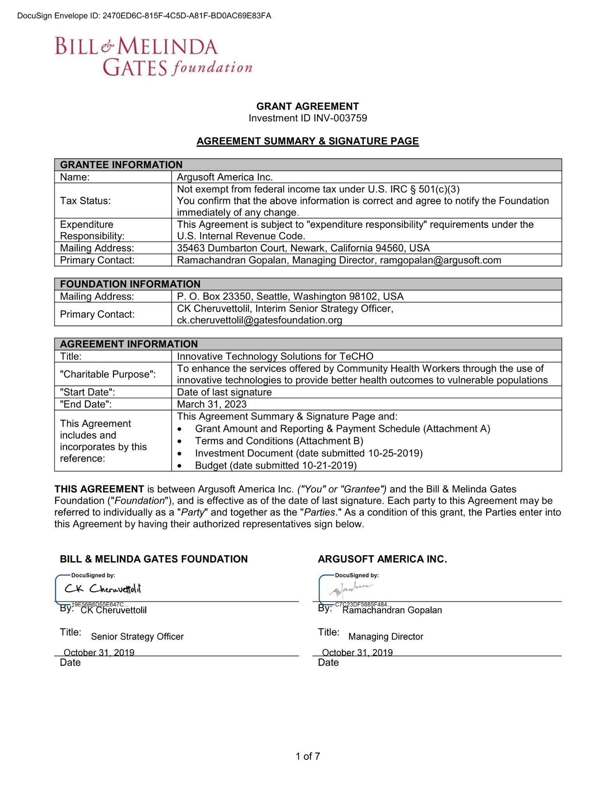

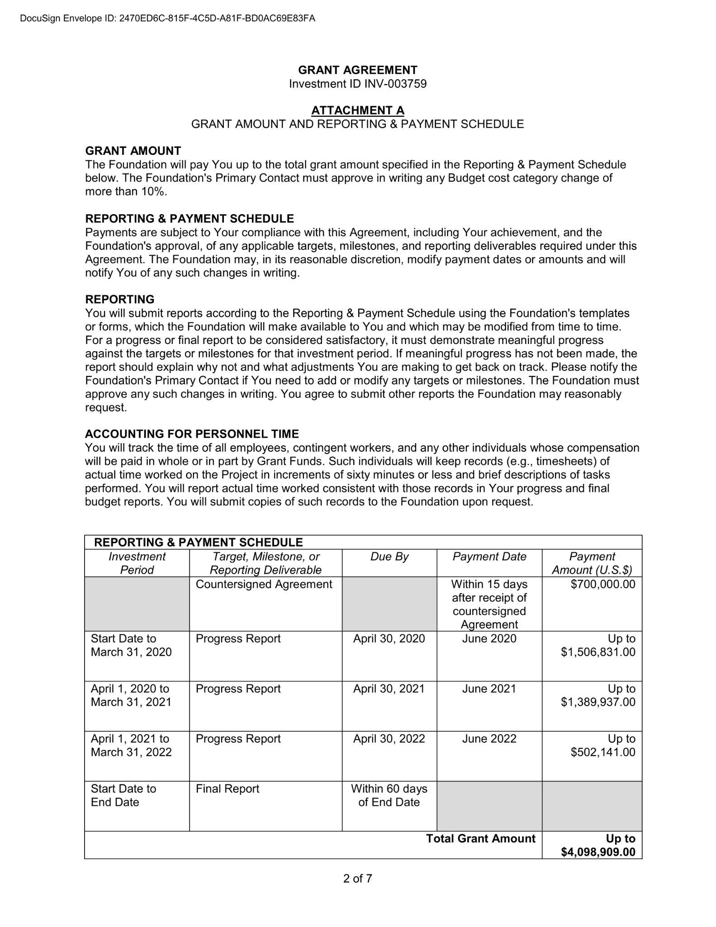

CHIP - Zambia
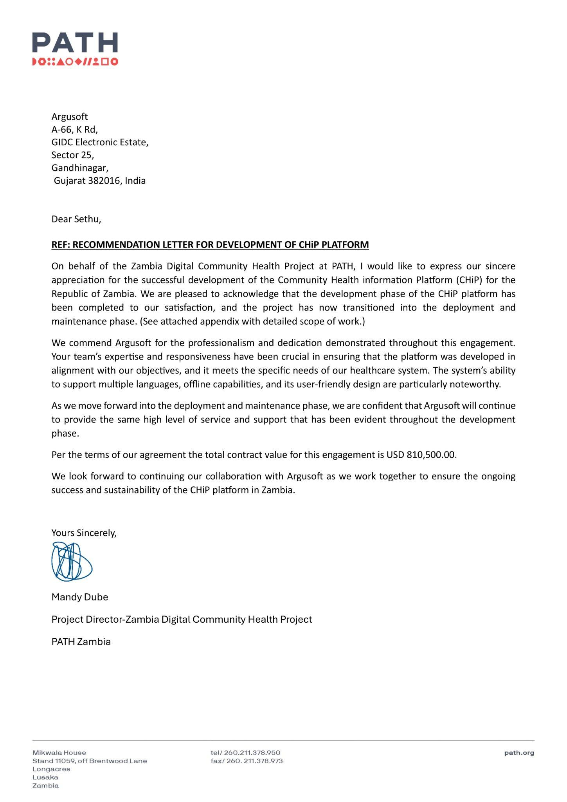

EWARS
Date | P.O. No. | P.O Amount (in INR) | Equivalent USD
3rd Dec 2019 | 202461882 | ₹11,831,437.50 | $142,547.44
11th Mar 2020 | 202526017 | ₹9,690,798.32 | $116,756.61
03rd June 2020 | 202551413 | ₹8,702,917.50 | $104,854.43
11th Aug 2020 | 202574084 | ₹9,360,417.24 | $112,776.11
25th Nov 2020 | 202614690 | ₹9,275,386.27 | $111,751.64
7th Dec 2020 | 202619793 | ₹6,608,071.00 | $79,615.31
24th Feb 2021 | 202649139 | ₹6,756,201.00 | $81,400.01
6th Dec 2021 | 202784268 | ₹6,113,472.00 | $73,656.29
4th July 2022 | 202900643 | ₹6,367,248.00 | $76,713.83
3rd Jan 2023 | 203040821 | ₹2,550,240.00 | $30,725.78
8th Mar 2023 | 203091310 | ₹5,102,944.00 | $61,481.25
25th Aug 2023 | 203202145-1 | ₹5,288,154.00 | $63,712.70
5th Jan 2024 | 203340939 | ₹5,354,280.00 | $64,509.40
8th July 2024 | 203478061 | ₹7,761,780.00 | $93,515.42
16th Dec 2024 | 203604220 | ₹7,853,850.00 | $92398.23
16th May 2025 | 203671255 | ₹7,936,620.00 | $93372.00
Total |  | ₹116,553,816.83 | $1,399,786.45
The total cumulative value of the EWARS contract is ₹116,553,816.83, equivalent to approximately USD 1,399,786.45.
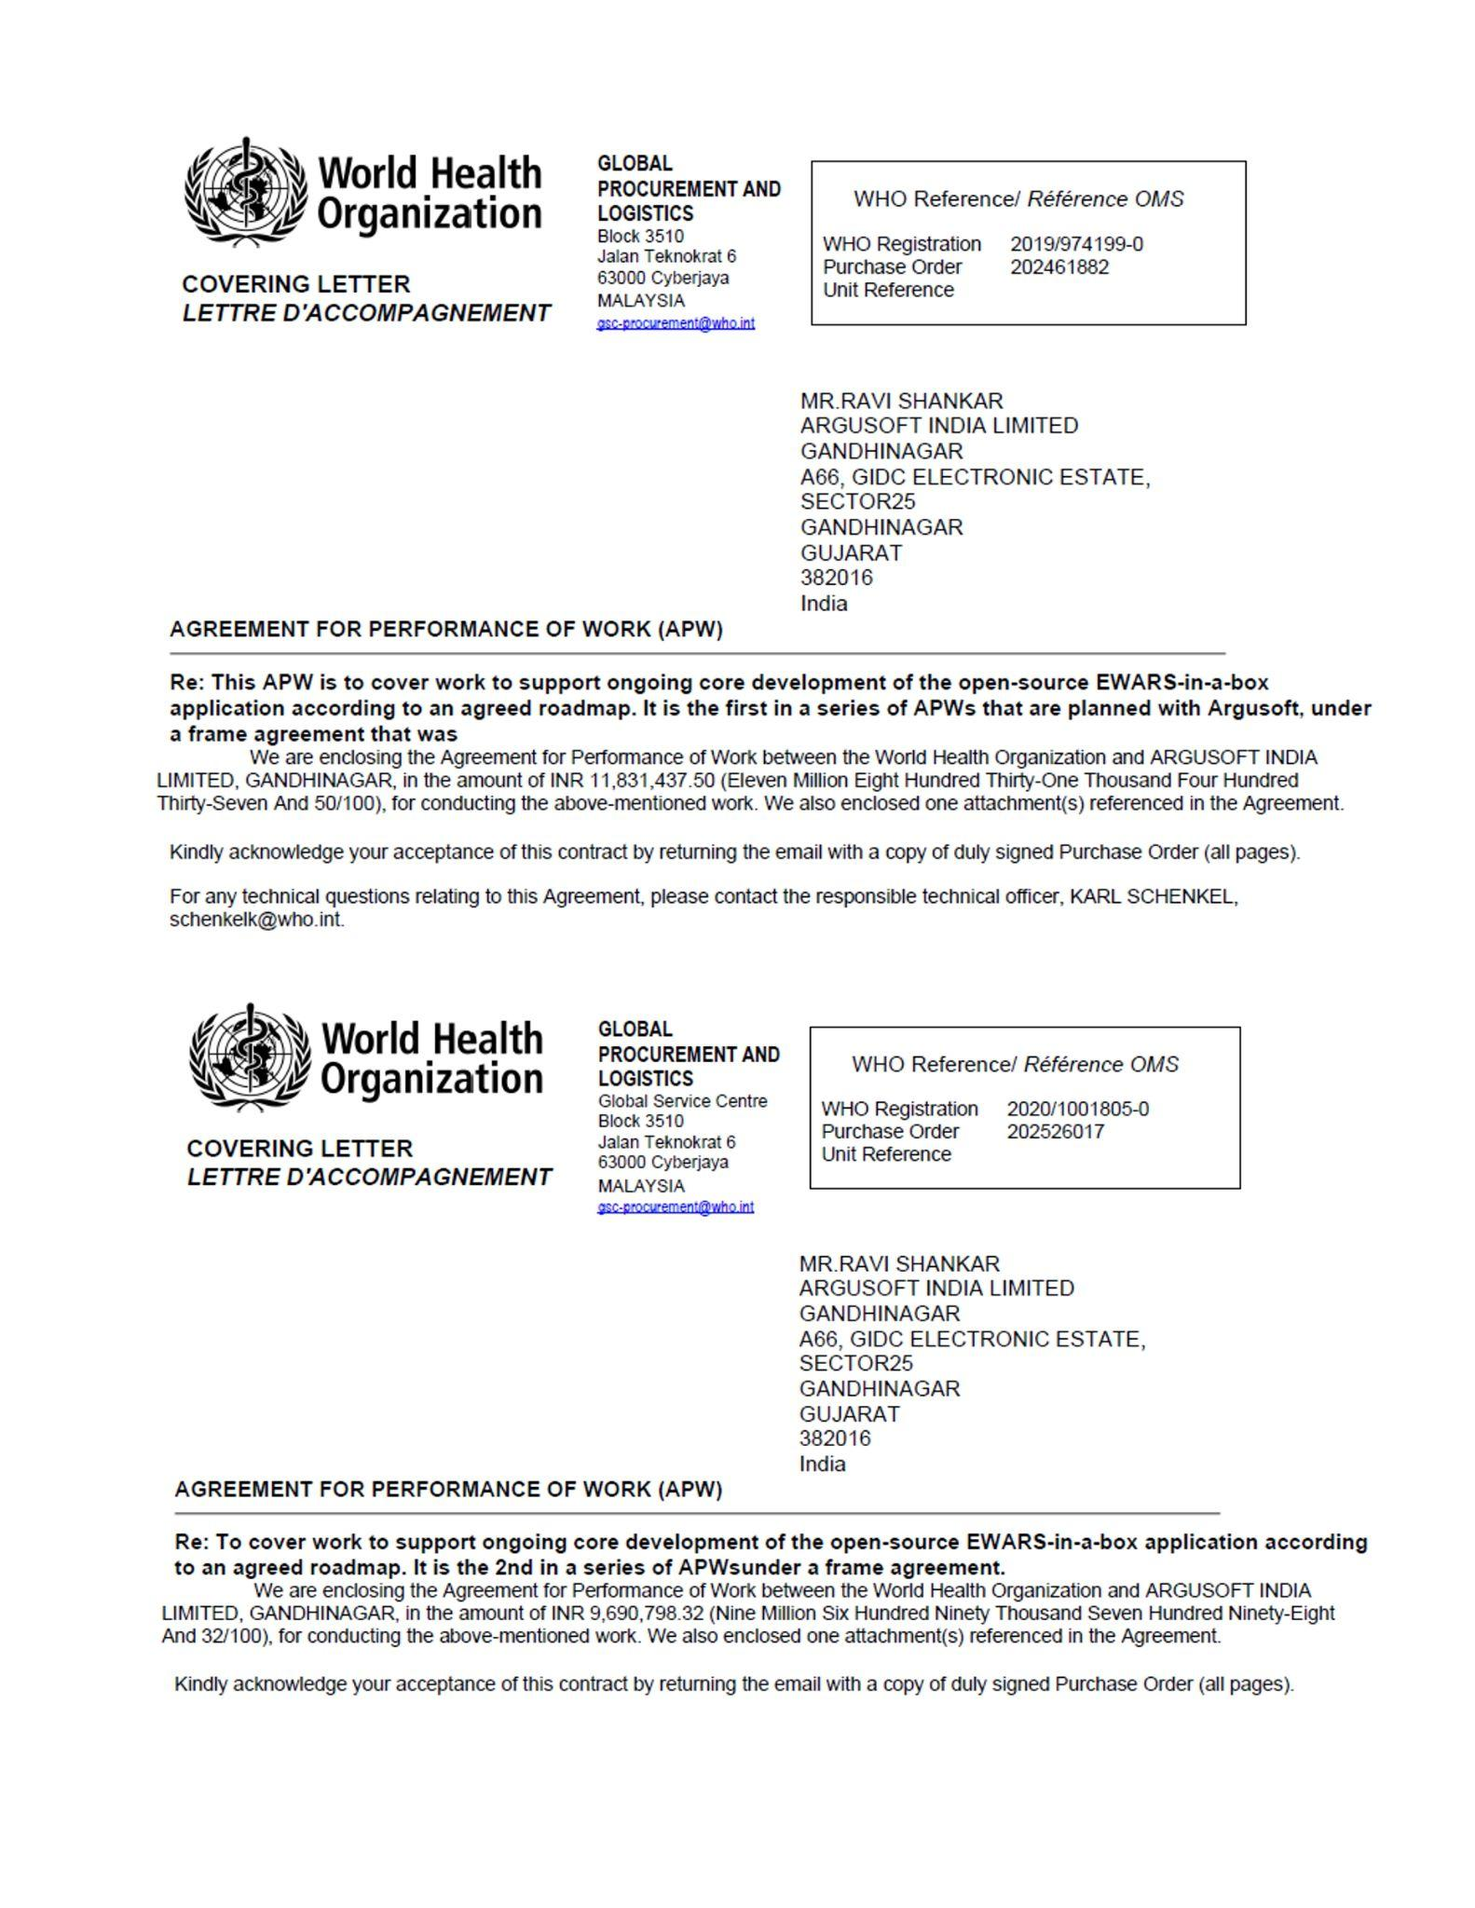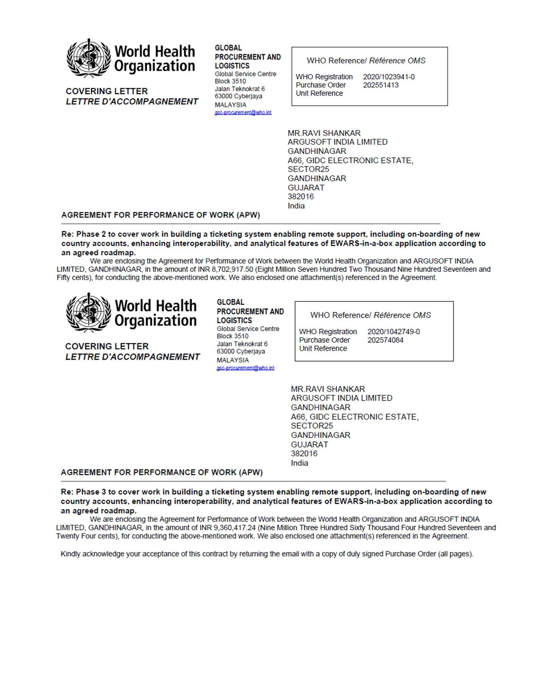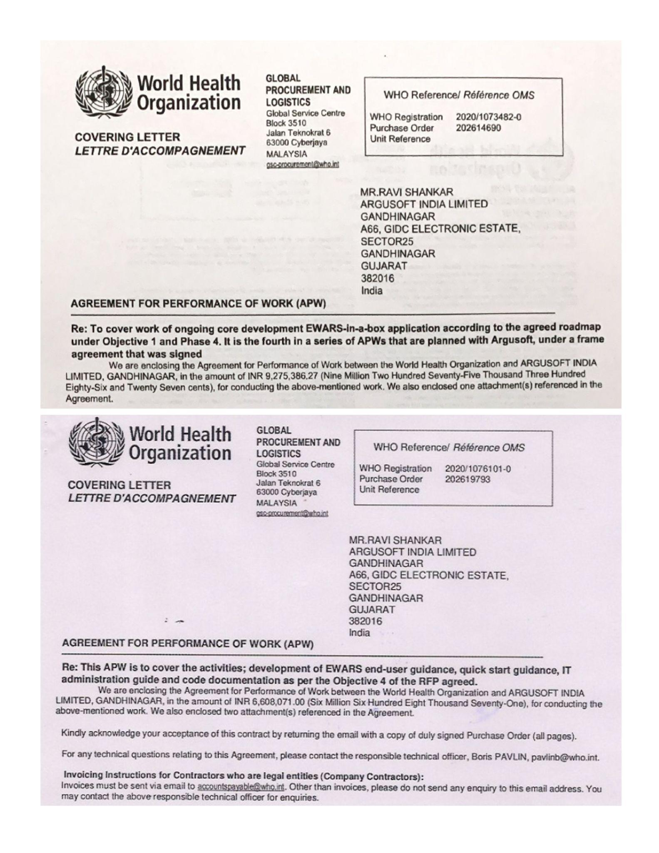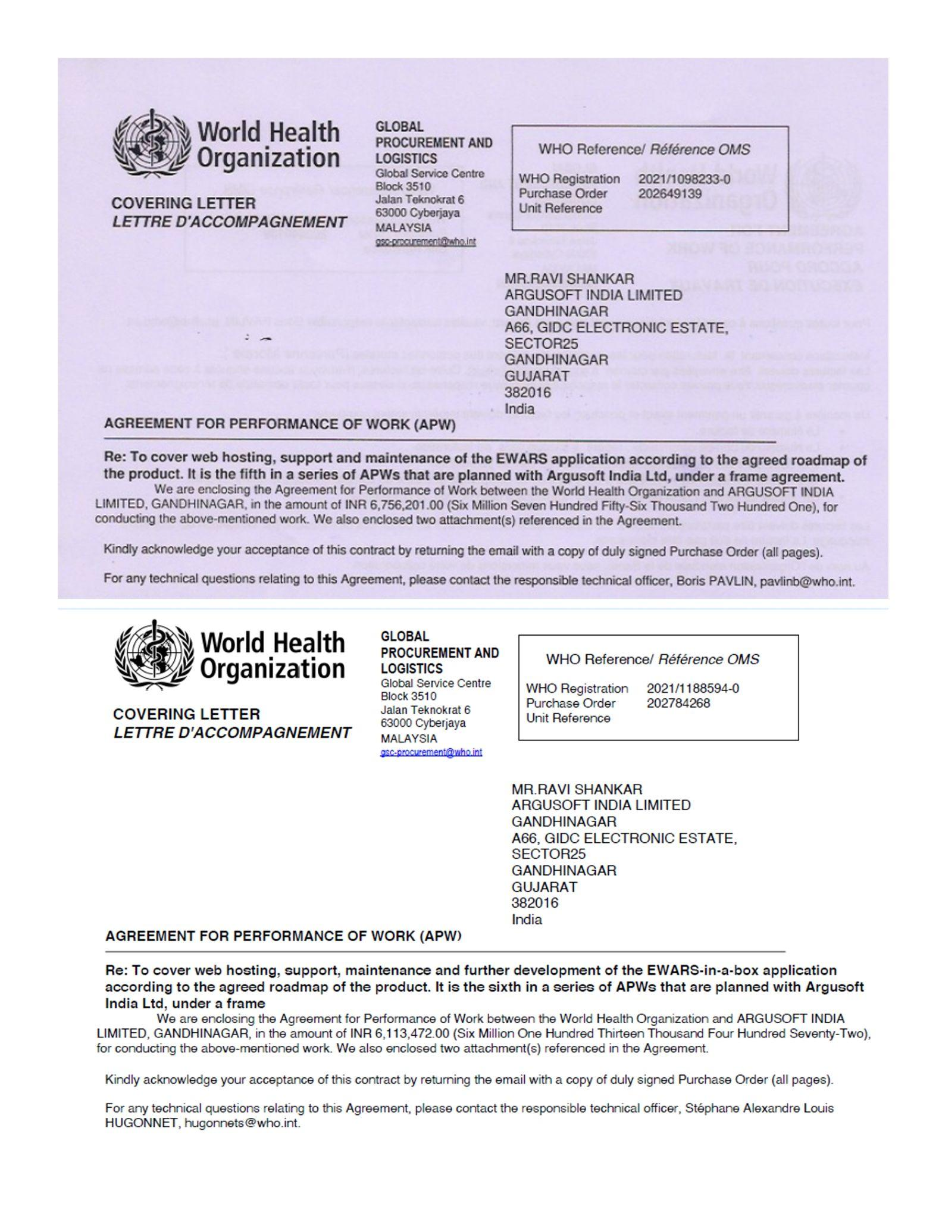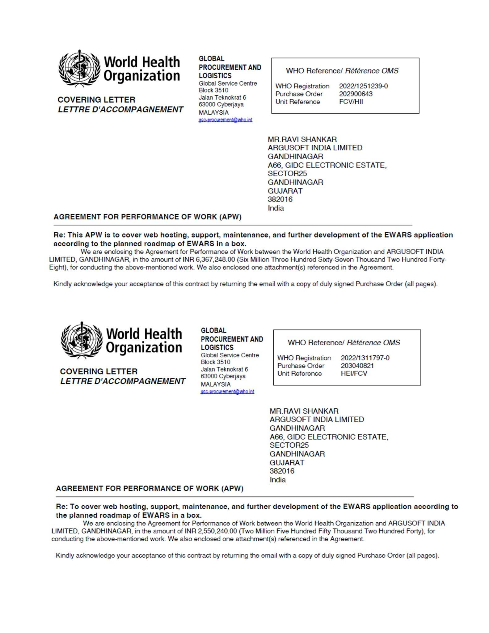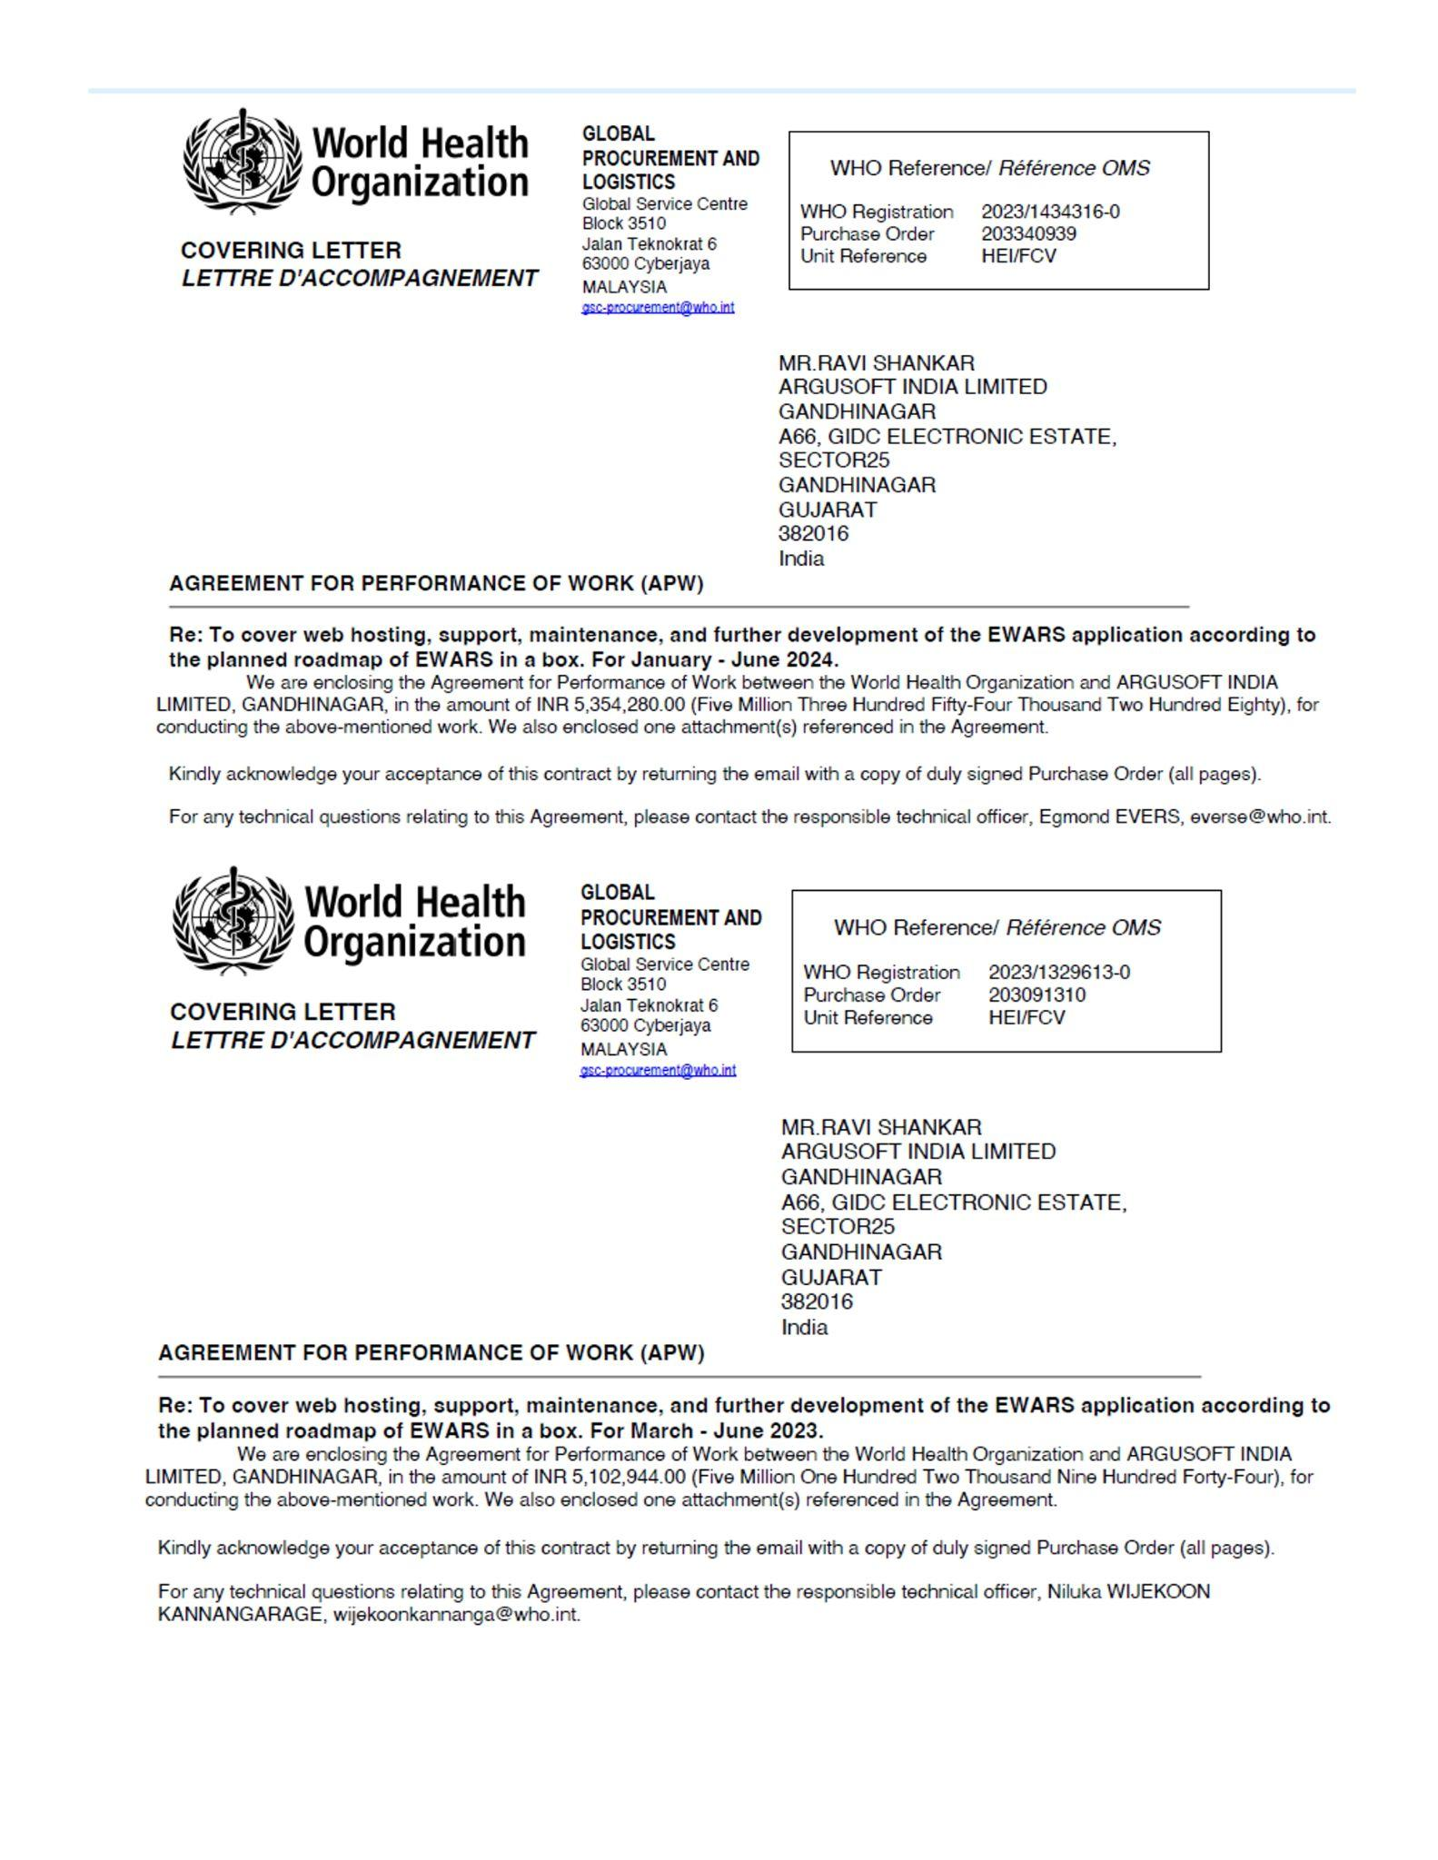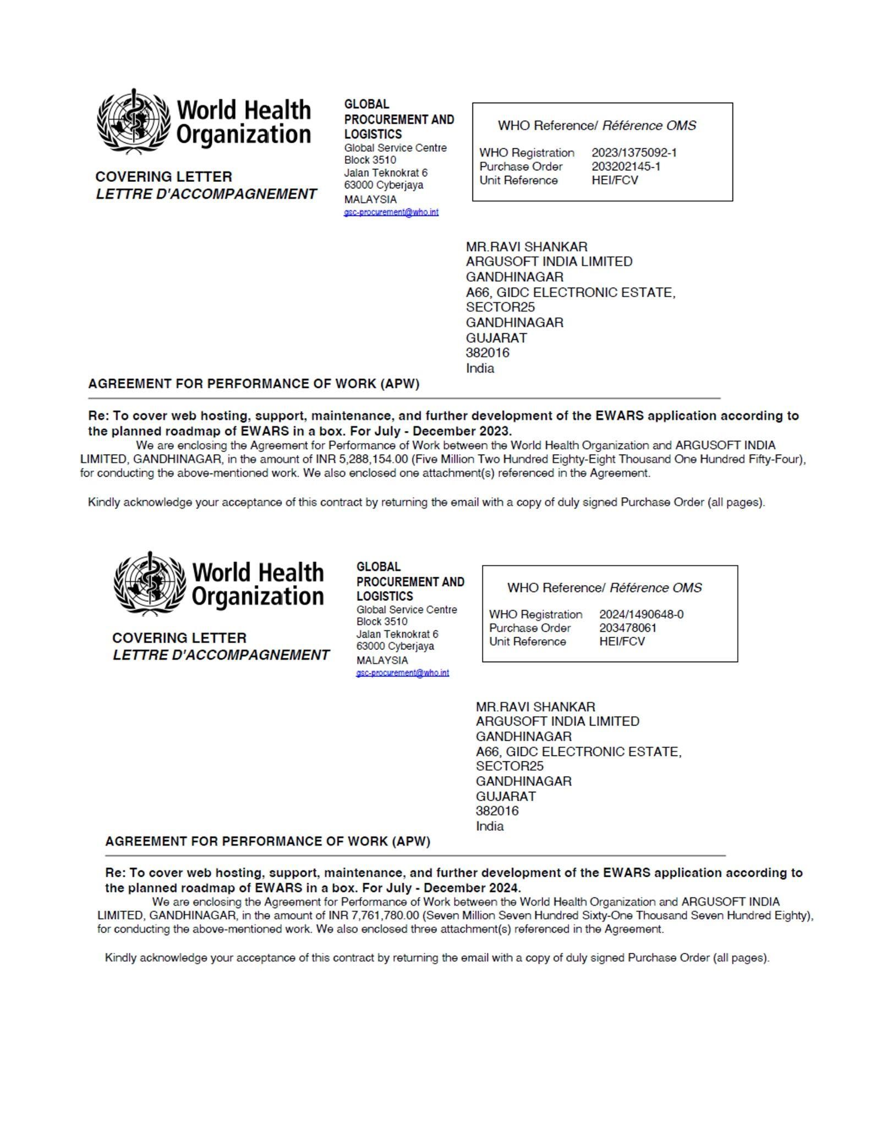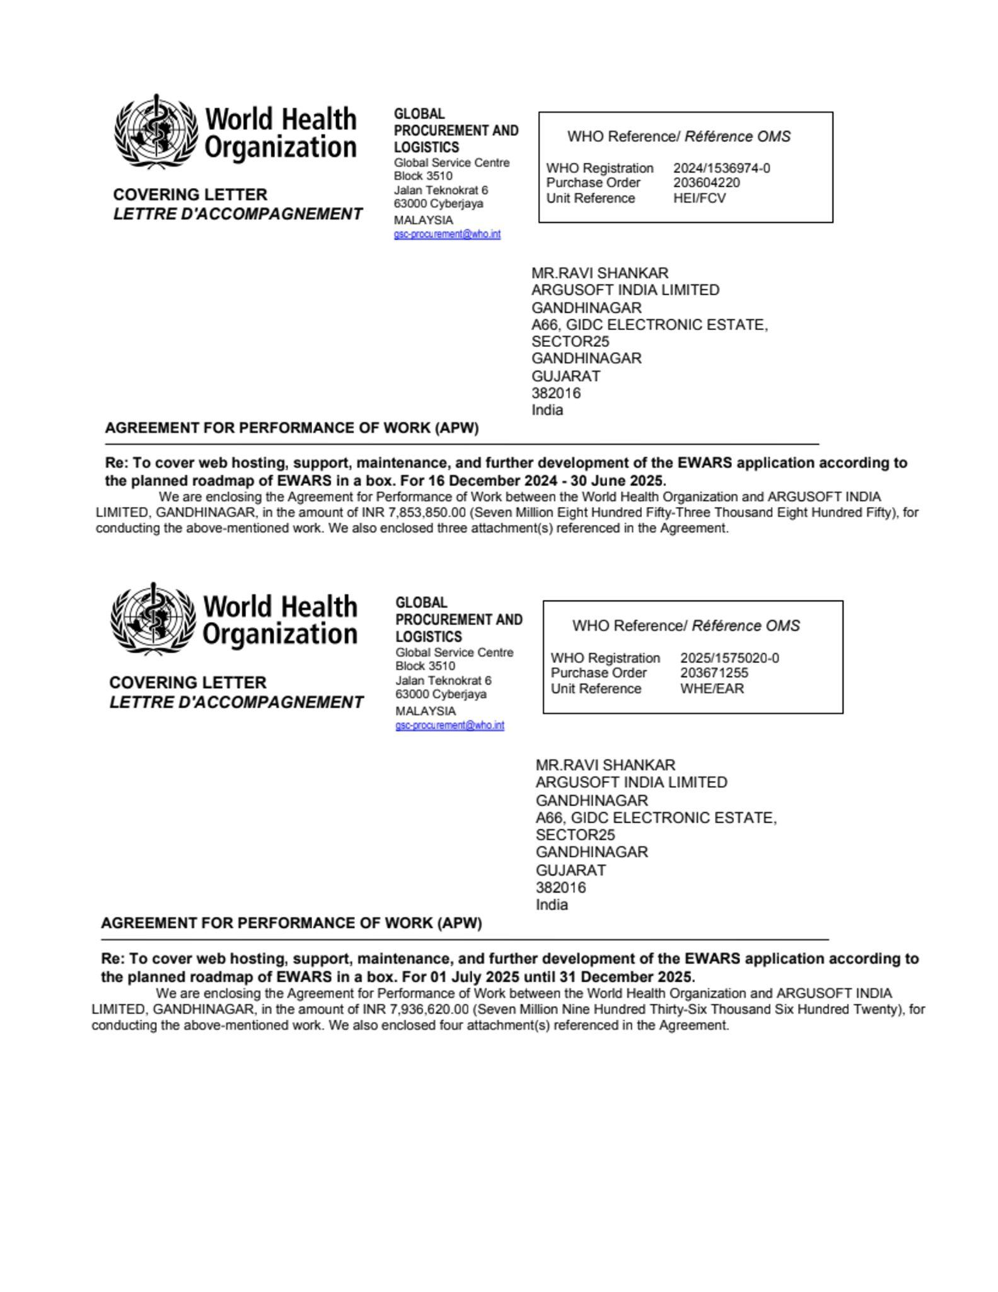

PPC, Jamaica

Date | Title/Description | Contract No | Quotation (USD)
28th January, 2025 | Consultancy services for Data Visualization and Business Intelligence (DVBI) Portal Refinement | PPC-PROC#0752/2024 | $67,200.00
3rd December, 2024 | Provision of consultancy services for maintenance and technical services support for PPC applications - Data Visualization and Business Intelligence (DVBI), Procurement Endorsement Database Management (PEDMS), and the PPC website | PPC-PROC#0722/2024 | $66,000.00
30th June, 2024 | Consultancy services for Application Programming Interface Development for the Integration between GOJEP and PEDMS | PPC-PROC#0552/2024 | $33,000.00
31st October, 2023 | Provision of consultancy services for maintenance and technical services support for PPC applications - Data Visualization and Business Intelligence (DVBI), Procurement Endorsement Database Management (PEDMS), and the PPC website | PPC-PROC#0448/2023 | $41,600.00
19th August, 2022 | Consultancy Services for Data Visualization and Business Intelligence (DVBI) Portal Refinements | PPC-PROC#0222/2022 | $54,000.00
15th June, 2022 | Development of the Procurement Endorsement Database Management System (PEDMS) | PPC-PROC#160/2022 | $156,950.00
2nd November, 2021 | Design and Development  of the Data Visualization and Business Intelligence (DVBI) Portal for Contractor Performance | PPC/CME/01-21 | $133,750.00
March, 2021 | Provision of Consultancy services for design and development of Public Procurement Commission Website | PPC/ICT/04-20 | $48,000.00
 | Total: |  | $600,500.00

SOFY, KPMG

Date | P.O. Number | PO Amount (in USD)
11th July 2025 | #0000063403 | $210,000.00
5th May 2025 | #0000061228 | $210,000.00
18th Feb 2025 | #0000058680 | $210,000.00
27th Oct 2024 | #0000054669 | $210,000.00
14th Aug 2024 | #0000052077 | $170,000.00
8th May 2024 | #0000049395-2 | $162,500.00
25th Feb 2024 | #0000046345 | $222,000.00
27th Oct 2021 | #0000015118 | $750,000.00
11th Aug 2020 | #0000006274 | $580062.50
 | Total | $2724562.5

